Six Essential Components of Play-Based Story Creation
  - Reflecting on Instruction

Reflecting on Instruction
We encourage you to videotape your lesson periodically so you can reflect on the efficacy of your instructional strategies. Though we always hope for perfection when delivering instruction for our student, frequently there are things that need to be adjusted or expanded in our instruction. This may be related to brilliant ideas that just didn’t work for a specific student or changes that the student has made since the lesson was originally planned.

It is very helpful to reflect on your teaching strategies and make necessary changes to your lesson. What did you do that was especially effective? What would you do differently the next time?

Use the chart that follows to make notes for yourself about the lesson you provided:

- When you review the video you have made of a lesson, note examples of the six essential components you observed.
- Reflect and note effective and ineffective strategies and ideas for improving your instruction.

Six Essential Components |  | Examples of 6 essentials observed in video of activity | Reflection notes to adjust Instruction
 | - Builds on student’s strengths and interest, opportunity for choice-making
 | - Includes peers in the interaction
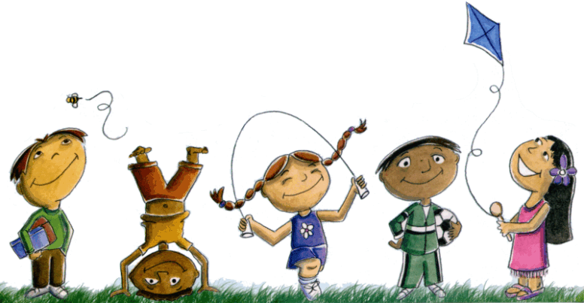 | - Creates an atmosphere of play (social and/or symbolic) with modeling and encouragement
 | - Provides a context for activity through predictable routines, consistent and accessible locations, adequate space for enactment and story creation
 | - Includes the use of props and actions and physical enactment
 | - Adult is flexible and supportive and provides scaffolding between highly directive and participatory role and non-directive encourager and scribe.

