Catch the Rhyme!

Poetry Readings with Young Ant

Wednesday, April 21

7:00 pm EDT/4:00 pm PDT

~ For blind kids & friends ~

Registration:

https://bit.ly/2Q5SlUr

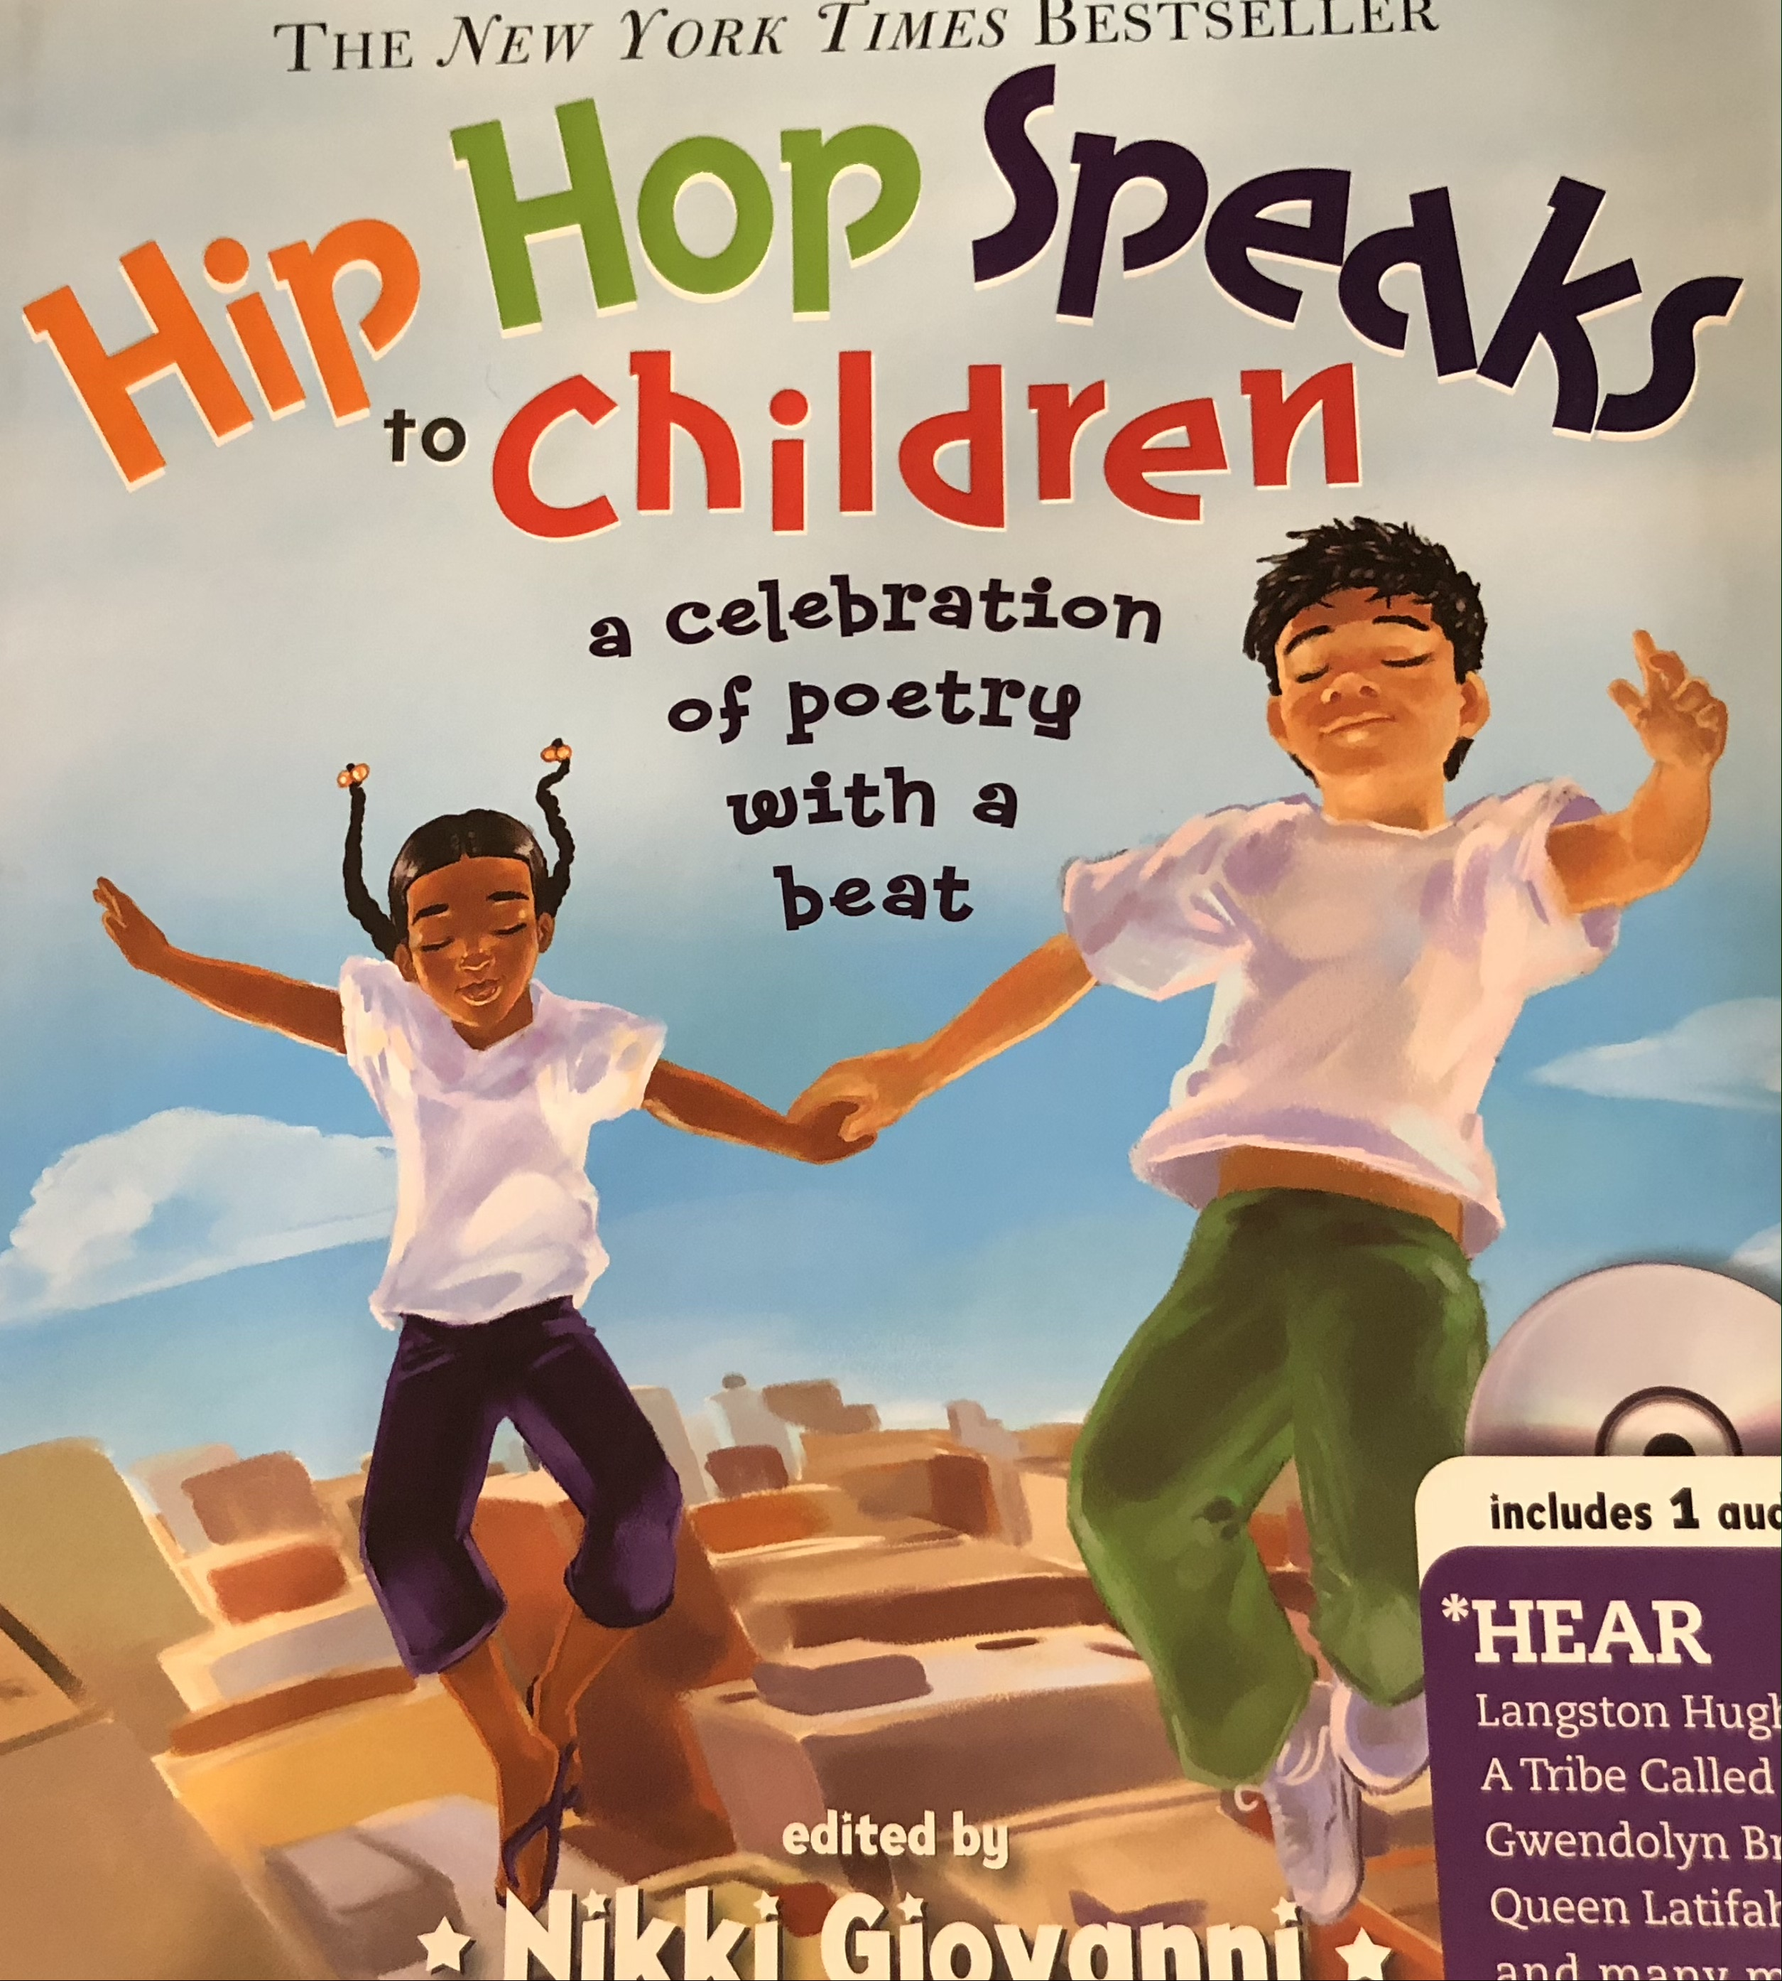
In celebration of National Poetry Month, join Monique Coleman and hip-hop artist Young Ant who will read poems from Hip Hop Speaks to Children: A Celebration of Poems with a Beat
Young Ant, whose song Stick Walk is an anthem for the white cane, will also share her creative process for writing rhymes.
Do You Know a Kid with a Poem to Share?
Kids ages 5-16 can submit their original poems for us to read. Each person who submits a poem that meets the guidelines will get a prize.
For more info and to submit a poem, email info@vistaseducation.com

