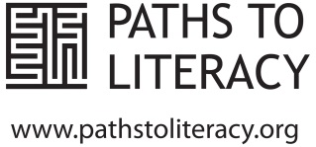 Name: _____________________

Paths to Literacy Scavenger Hunt!

Use the Paths to Literacy website www.pathstoliteracy.org to find the following. Write the URL in the line provided.

- Find a strategy for modifying books for students with CVI.

________________________________________________________________

- Find information about learning media assessments for students with multiple disabilities.

________________________________________________________________

- Find a quick reference sheet about some of the key differences between EBAE and UEB.

________________________________________________________________

- Find information about creating experience books or stories

________________________________________________________________

- Find a tip sheet about the technology needs of a college-bound academic braille-user.

________________________________________________________________

