Train Whole Word Contractions Braille
Words- A, But, Can, Do, Every, Go, Like, So, It, You, People and Rather

Created By: Samantha Zauner

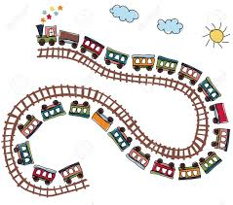

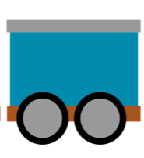
Go
A

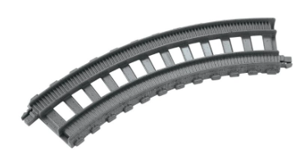

Like
Can

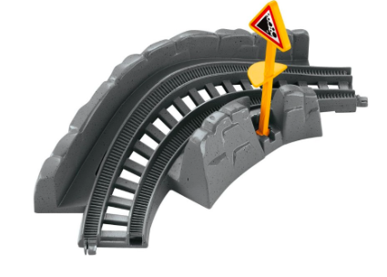

So
Rather

Do
You
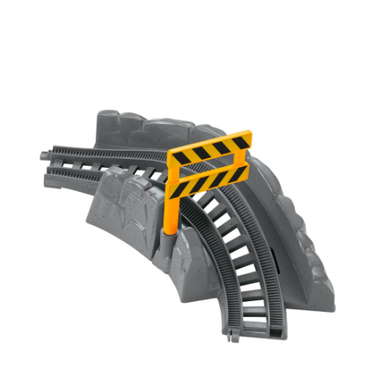

People
It

Every
But

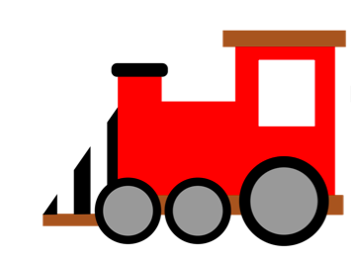
Dot 1
Dot 1, 2 and 3

Dot 1, 2, 3 and 5
Dot 1, 2, 4 and 5

Dot 1, 3, 4, 5 and 6
Dot 1 and 4

Dot 2, 3 and 4
Dot 1, 3, 4 and 6

Dot 1 and 2
Dot 1 and 5

Dot 1, 2, 3 and 4
Dot 1, 4 and 5

Answer Sheet

Visual | Dot Formation | Word
A | Dot 1 | A
B | Dot 1 and 2 | But
C | Dot 1 and 4 | Can
D | Dot 1, 4 and 5 | Do
E | Dot 1 and 5 | Every
G | Dot 1, 2, 4 and 5 | Go
L | Dot 1, 2 and 3 | Like
S | Dot 2, 3, and 4 | So
X | Dot 1, 3, 4 and 6 | It
Y | Dot 1, 3, 4, 5 and 6 | You
P | Dot 1, 2, 3 and 4 | People
R | Dot 1, 2, 3 and 5 | Rather

