UEB Lesson 6:
Miscellaneous Symbols

By Catherine Summ and Suzanne Cappiello
Goal: The student will be able to identify common miscellaneous symbols in UEB.
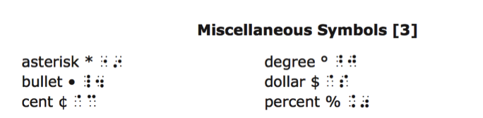
(These are symbols commonly found in general, academic, and technical reading materials.)

For an explanation of the changes refer to the handout “Overview of Changes from Current Literary Braille to Unified English Braille” authored by Braille Authority of North America (BANA), March 2013, http://www.brailleauthority.org. Refer to the UEB manual for a full explanation of the braille code.

Procedure:
Teacher prepares sentences below. Students read the following literary sentences then mark the miscellaneous symbols now used in UEB. The special treat is for him, her… and you.
- He gave Wally $8.
- The temperature fell 20°.
- She paid $120 per day for the car rental.
- The children only made 76¢ from their lemonade stand.
- His friend gave him $10 and 50¢ to buy snacks for the party.
- The little league player increased his batting average by 45% this season.
- I want to be 100% sure.
- *See glossary.
- 29°C is very hot.
- Here is the list:
- Milk
- Eggs
- Bread

Additional Activities: Writing Practice
Students read sentences below already prepared in braille by the teacher using the new UEB miscellaneous symbols. Students mark the miscellaneous symbols now used in UEB. “Hmm…” said Tom, thoughtfully.
- Dial *211 for the cafeteria.
- The average high temperature in January for Milwaukee, WI, is 26°F.
- 42% of student scores were in the above average range.
- Wally needed 38¢ more to buy his favorite smoothie.
- The ingredients include:
- Sugar
- Vanilla
- Eggs
Assessment:
Teacher dictates the following sentences using the new miscellaneous symbols in UEB. Add your own. Teacher compiles a spreadsheet for each student to document progress and compile data.
- Bake the recipe for at 350° for 25-30 minutes.
- Sally dialed *411 for information.
- Freddy’s team won the championship and now hold the #1 position in the state.
- He needed to beat his best running time by 24%.
- I will need the following supplies:
- Paper
- Stapler
- Packing tape

Educational Activity and Game:
Song: A $illy $lipper $nake
Read and Sing to the tune of: “If you’re happy and you know it”
Oh, I wi$h I wa$ a $illy, $lippery $nake.
Oh, I wi$h I wa$ a $illy, $lippery $nake.
Oh I’d $lither across the floor,
And I’d $lither under the door.
Oh, I wi$h I wa$ a $illy, $lippery $nake.

Tongue Twister:
$ally $ells $ea $hells by the $ea $hore
Joke:
Did you hear about the $3,000,000 Kentucky State Lottery?
The winner gets $3 a year for a million years!
Recipe:
Making Sandwich Wraps
Students will read the recipe below and then make their own sandwich wraps.
Materials:
- Wrap tortillas
- Mayonnaise
- Cheese slices
- Lunch meat
- Lettuce & tomato
- Knives & cutting board
Use back end of large spoon to spread mayonnaise using a pattern-side to side then up and down. Be aware of edges
How to wrap:
- Position the ingredients in a small rectangle on the bottom half of a round tortilla.
- Fold in two sides until they meet in the center.
- Fold the bottom of the tortilla to the center over the filling
- Continue rolling.
- Place seam side down

To see more UEB lessons, visit: http://www.pathstoliteracy.org/blog/ueb-curriculum-braille-students

