Drum Braille 2
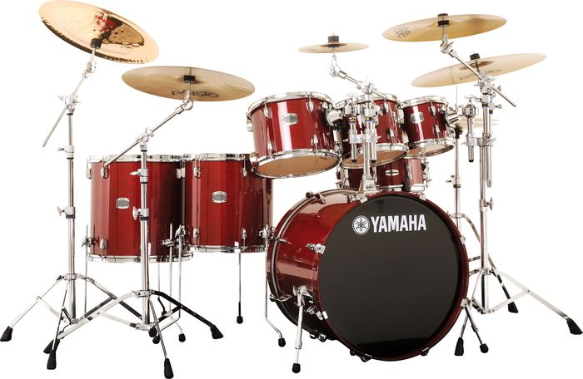

Created by: Samantha Zauner

Purpose: This file folder game can be used with low vision students who are beginning to learn braille.

Suggestion: Add the appropriate braille symbol using adhesive braille paper to the baseball cutout to provide a reading experience.

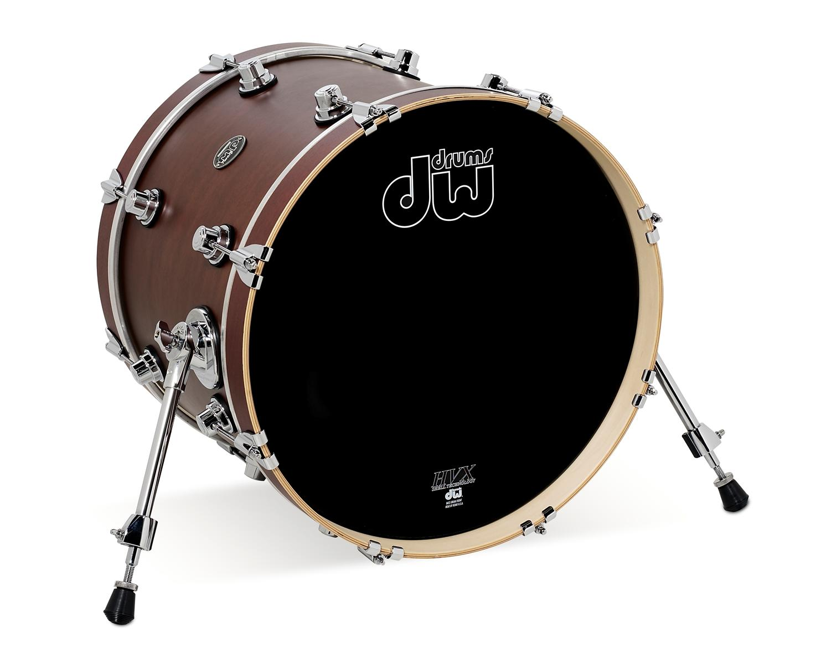

Dots 1, 3, 4 and 6

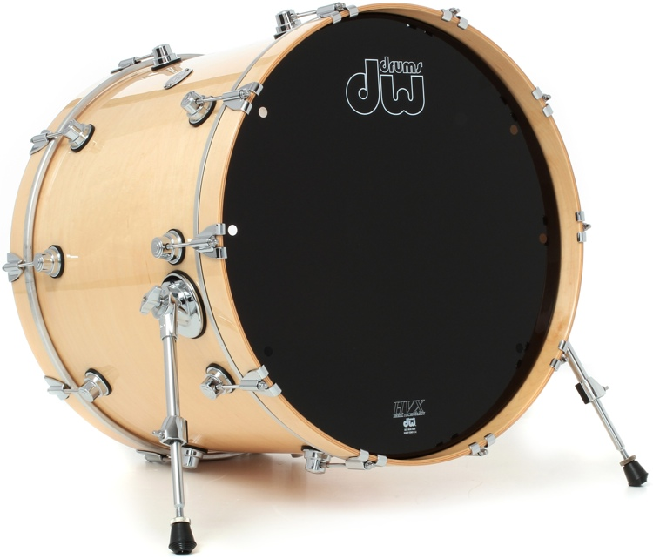

Dots 1, 3, 4, 5 and 6

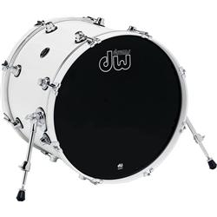

Dots 1, 2 and 4

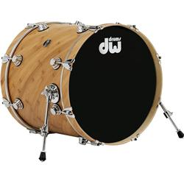

Dots 1, 2, 3 and 5

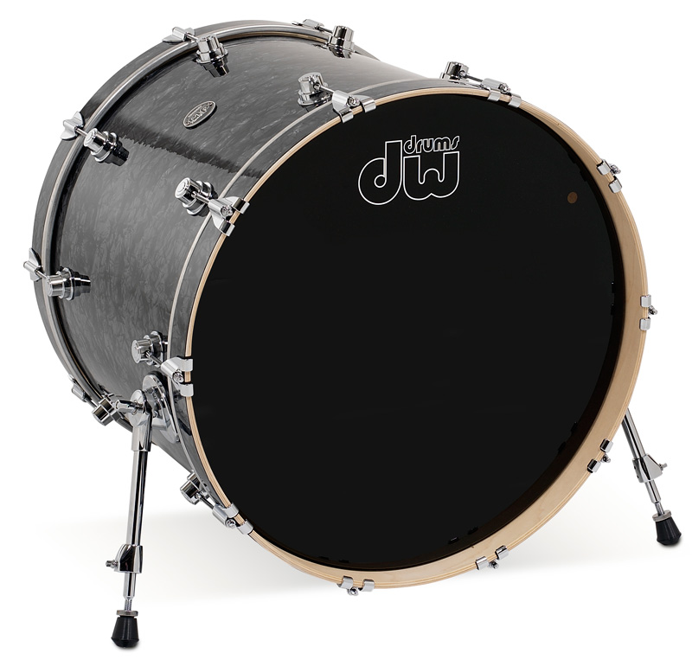

Dots 1, 4 and 5

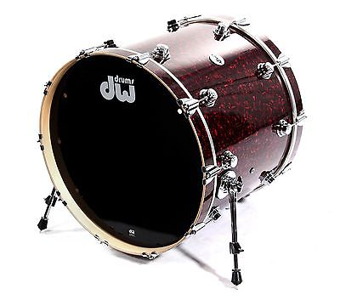

Dots 2, 4, 5 and 6

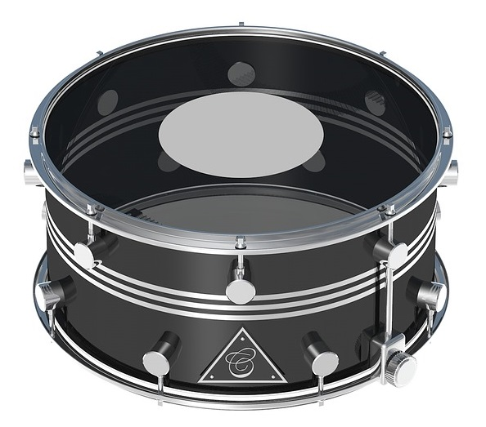
D
F
W
R
Y
X

(images on this page from pixabay.com)
Answer Sheet

Visual | Dot Formation | Letter
F | Dot 1, 2 and 4 | F
D | Dot 1, 4 and 5 | D
X | Dot 1, 3, 4 and 6 | X
Y | Dot 1, 3, 4, 5 and 6 | Y
R | Dot 1, 2, 3 and 5 | R
W | Dot 2, 4, 5 and 6 | W

