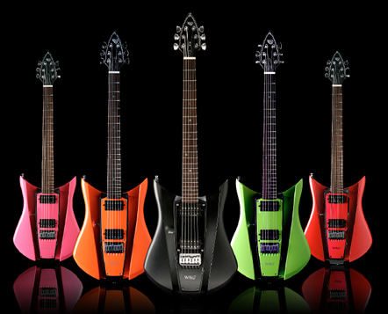

Guitar Braille

Letters- A, B, C, D, E and G

Created By: Samantha Zauner

**Purpose:** This file folder game can be used with low vision students who are beginning to learn braille.

**Suggestion:** Add the appropriate braille symbol using adhesive braille paper to the guitar cutout to provide a reading experience.

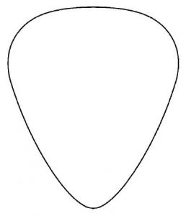

**Dot 1, 4 and 5**

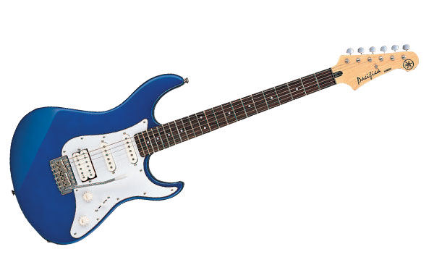

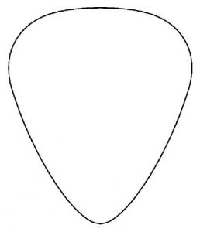

**Dot 1**

**and 2**



**Dot 1**

**and 4**

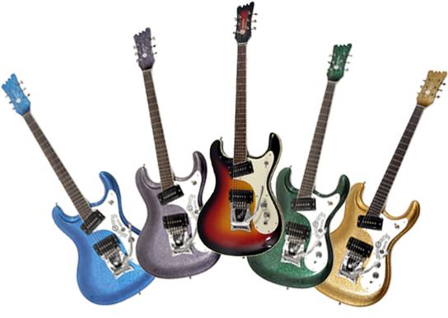



**Dot 1, 2, 4 and 5**

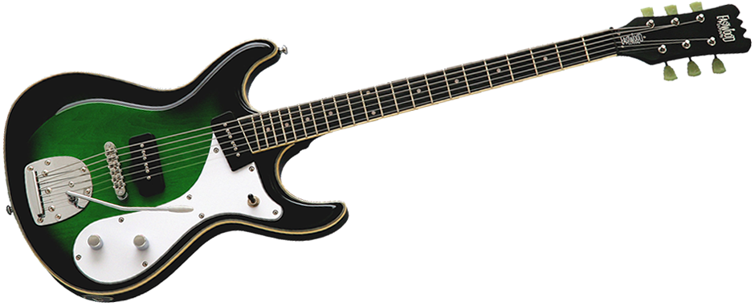



**Dot 1 and 5**

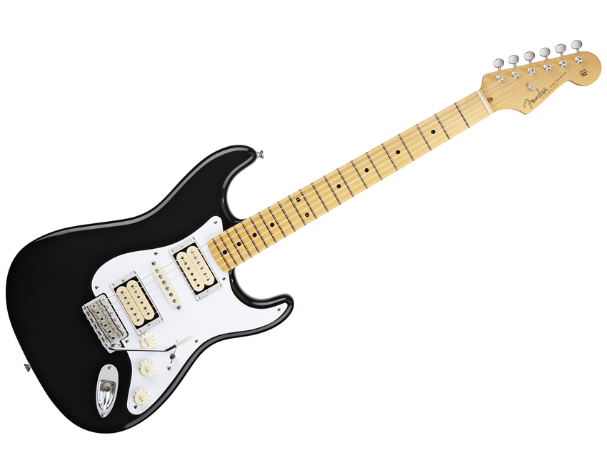



**Dot 1**

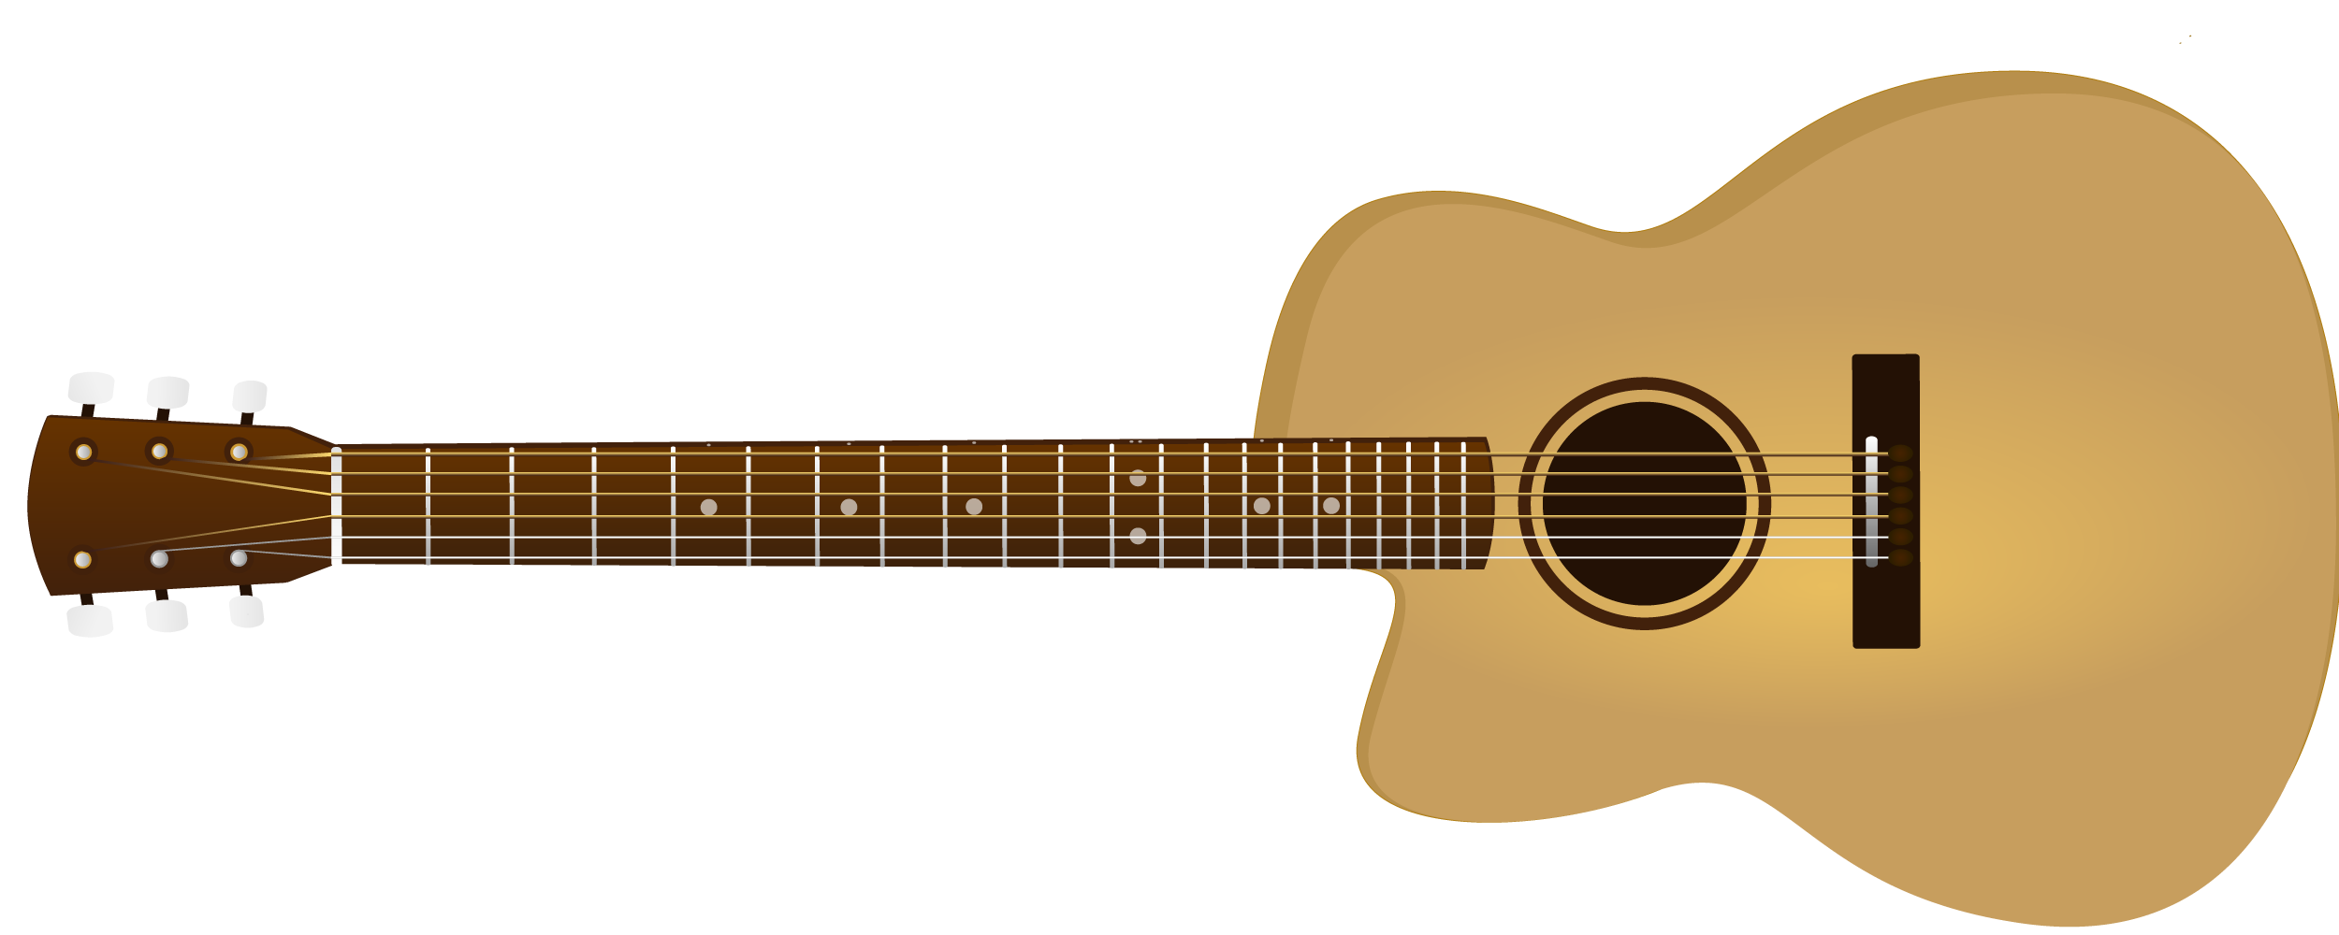









**A**



**B**









**C**



**D**



**G**

**E**