Instruction for a Holiday Wreath #3 by Edith West
Row 1: Space 7 times, make “was”, make “with”, make 5 full cells, make “of”, make “were”, make “his”, space 2 times, make “ar”, make :gh”, make “was”, make “were”, make “with”, make 5 full cells, make “of”, make “his”.
Row 2: Space 6 times, make “with”, make “f”, space 4 times, make “was”, make “were”, make “d”, make “er”, make 1 full cell, make “ar”, make letter “l”, space 1 time, make “gh”, make “q”, make “were”, make “his”, space 4 times, make “d”, make 1 full cell, make “of”.
Row 3: Space 6 times, make 2 full cells, space 2 times, make “was”, make “with”, make 6 full cells, make “ar”, make letter “l”, space 1 time, make 4 full cells, make “of”, make “his”, space 2 times, make 2 full cells
Row 4: Space 1 time, make “d”, make 1 full cell, make “of”, space 1 time, make “was”, make “er”, make “f”, make “was”, make “with”, make 4 full cells, make “f”, make “c” 2 times, make “er”, make “i”, make “c”, make “f”, make “c” 2 times, make “d”, make 4 full cells, make “of”, make “his”, make “d”, make “q”, make “his”, space 1 time, make “with”, make 1 full cell, make “f”.
Row 5: Space 2 times, make “d”, make 1 full cell, make “q”, make ”f”, make “was”, make “with, make 6 full cells, space 3 times, make cell(4, 5, 6), make “c”, make “e”, make letter “l”, space 3 times, make 6 full cells, make “of”, make “his”, make “d”, make “er”, make 1 full cell, make “f”.
Row 6: Space 4 times, make “was”, make “with”, make 5 full cells, make “q”, make “f”, space 1 time, make “e”, make “hyphen” 2 times, make “i”, space 2 times, make “e”, make “hyphen” 2 times, make “i”, make, space 1 time, make 7 full cells, make “of”, make “his”.
Row 7: Space 3 times, make “with”, make 6 full cells, make “q”, make “f”, make “e”, make “hyphen” 2 times, make “i”, make “st”, make “e”, make “hyphen” 2 times, make “i”, space 1 time, make “e”, make “hyphen” 2 times, make “i”, make “d”, make “er”, make 6 full cells, make “of”.
Row 8: Space 2 times, make “with”, make 7 full cells, make “f”, space 1 times, make “gh”, make letter “l”, make “ar”, make 1 full cell, make “gh”, make cell (4, 5, 6,), space 1 time, make “gh”, space 2 times, make full cell, space 4 times, “d”, make 7 full cells, make “of”.
Row 9: Space 1 times, make “with”, make 7 full cells, make “f”, space 5 times, make full cell, space 1 time, make “e”, make “i”, space 3 times, make full cell, space 5 times, make “d”, make 7 full cells, make “of”.
Row 10: Make cell dots (5, 6), make 7 full cells, make “f”, space 4 times, make “was”, make 1 full cell, make “f”, space 6 times, make “d”, make 1 full cell, make “his”, space 4 times, make “d”, make 7 full cells, make “semicolon”.
Row 11: Make “with”, make 7 full cells, space 5 times, make 1 full cell, make “of”, Make “were” 8 times, make “with”, make 1 full cell, space 5 times, make 7 full cells, make “of”.
Row 12: Make 8 full cells, space 10 times, make “er”, make “q”, space 10 times, make 8 full cells.
Row 13: Make 8 full cells, space 22 times, make 8 full cells.
Row 14: Make “er”, make 7 full cells, space 22 times, make 7 full cells, make “q”.
Row 15: Make cell dots (4, 5), make 7 full cells, make “his”, space 20 times, make “was”, make 7 full cells, make “b”.
Row 16: Space 1 time, make “er”, make 7 full cells, make “his”, space 18 times, make “was”, make 7 full cells, make “q”.
Row 17: Space 2 times, make “er”, make 6 full cells, make “of”, make “his”, space 16 times, make “was”, make “with”, make 6 full cells, make “q”.
Row 18: Space 3 times, make “er”, make 7 full cells, make “of”, make “his”, space 12 times, make “was”, make “with”, make 7 full cells, make “q”.
Row 19: Space 4 times, make “d”, make “er”, make 7 full cells, make “of”, make “his”, space 8 times, make “was”, make “with”, make 7 full cells, make “q”, make “f”.
Row 20: Space 6 times, make “d”, make “er”, make 22 full cells, make “q”, make “f”.
Row 21: Space 8 times, make “d”, make “er”, make 18 full cells, make “q”, make “f”.
Row 22: Space 10 times, make “d”, make “er”, make 14 full cells, make “q”, make “f”.
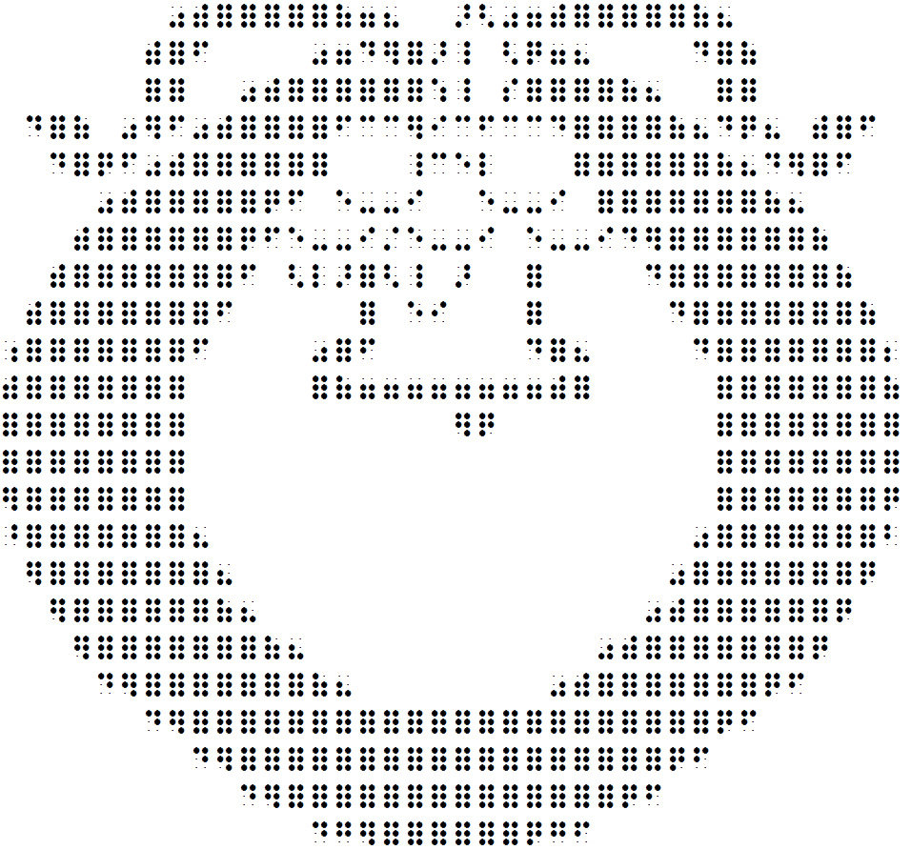
Row 23: Space 13 times, make “d”, make “g”, make “er”, make 6 full cells, make “q”, make “g”, make “f”.

Looks like this:

