Width of “Just for Fun” Patterns by Edith West
For reference, 29 Braille cells are accommodated on an 8 ½ X 11 braille paper, while 40 cells are accommodated on an 11 X 11 braille paper. Colored large paper can be purchased where scrapbooking supplies are sold.
All patterns were developed on a 40 cell width paper. The used cells may be reduced by subtracting the number of unused cells at the beginning of each row. I have noted the amount to be subtracted on the designs which can accommodate 29 cells on the instructions.
Note: Some shorter designs may be accommodated on 8 ½ X 11 if the paper can be turned landscape (sideways) in the brailler. The 8 ½” paper accommodates 17 rows. An example of this accommodation is the bat.
Just for Fun Design | UsedCells | 29 cell adjustment:  small paper
Angel 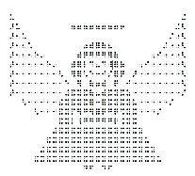 | 29 | 29 cell adjustment:  Subtract 3 spaces at the beginning of each Row
Apple 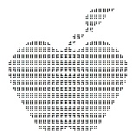 | 24 | none needed
Bat 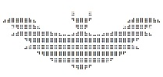 | 37 | 29 cell adjustment:  Landscape on short paper
Bird | 18 | none needed
Birthday Cake 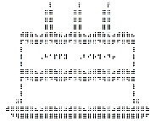 | 30 | 29 cell adjustment:  Subtract 2 spaces at the beginning of each row  Eliminate last cell on row 15  (Alternant method- Landscape paper)
Birthday Cake – Slice | 12 | none needed
Boat 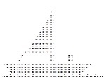 | 40 | 29 cell adjustment:  Landscape on short paper - Tight fit
Candy Cane  Candy Cane striped | 12 | none needed
Candy Canes (Double) 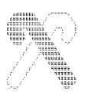 | 22 | none needed
Christmas Tree 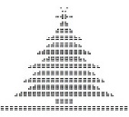 | 28 | none needed
Computer 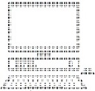 | 39 | Cannot be accommodated
Darth Vader | 40 | Cannot be accommodated
Dinosaur (T-Rex) 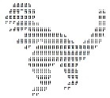 | 26 | none needed
Dragon 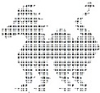 | 38 | Cannot be accommodated
Dreidel 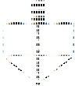  Dreidel with markings | 32 | Cannot be accommodated
Duck on Pond | 40 | 29 cell adjustment:  Eliminate last cells on last row
Easter Basket with eggs | 30 | 29 cell adjustment:  Subtract 3 of beginning spaces on each row  Row 3: eliminate 1 of the first “g”s  Rows 4-15: eliminate one space in middle of each row  Rows16-23 subtract one full cell from each row
Easter Eggs 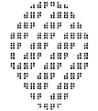 | 12 | none needed
Elf 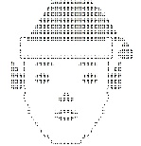 | 31 | 29 cell adjustment:  Subtract 4 spaces at the beginning of each row  Eliminate last cell on row 7  Eliminate last 2 cells on rows 8 & 9  (removes ball on hat)
Flower in a pot | 18 | none needed
Heart – Single 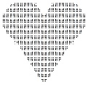 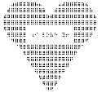  With or without message | 24 | none needed
Heart - Double 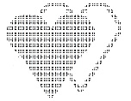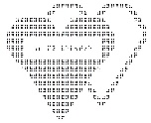  With or without message | 31 | 29 cell adjustment:  Landscape on short paper - Tight fit
Menorah | 40 | Cannot be accommodated
Pie  (This is done sideways and then turned) | 13 | none needed
Pirate Ship | 39 | 29 cell adjustment:  Landscape on short paper - Tight fit if you eliminate the first 4 rows
Pot of Gold | 37 | 29 cell adjustment:  Subtract 3 spaces at the beginning of each row  Eliminate end of row 16: make “with”, make 2 full cells, make “of”  Eliminate end of row 17: , make “er”, make 2 full cells, make “q”, Space 1 time, make “with”, make 2 full cells, make “of”  Eliminate end of row 18: make “er”, make 2 full cells, make “q”,  Eliminate end of row 19: make “with”, make 2 full cells, make “of”  Eliminate rows 20 & 21  (removes all but one fallen coin)
Pumpkin  Jack-o-lanterns | 34 | 29 cell adjustment:  Landscape on short paper - Tight fit
Pumpkin – Small 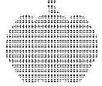 | 29 | none needed
Santa 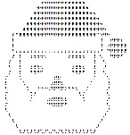 | 35 | Cannot be accommodated
Scarecrow 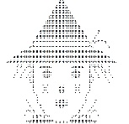 | 34 | 29 cell adjustment:  Subtract 4 spaces at the beginning of each row  Eliminate row 13  Eliminate any extra ending cells that do not fit  (Not as nice looking, but good enough)
Shamrock 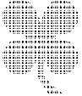 | 24 | none needed
Smilie Face | 17 | none needed
Snowman | 40 | Cannot be accommodated
Spider | 40 | 29 cell adjustment:  Landscape on short paper
Star of David 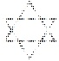 | 34 | Cannot be accommodated
Tow Truck 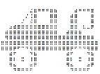 | 24 | none needed
Treasure Chest | 38 | 29 cell adjustment:  Landscape on short paper
Tulips 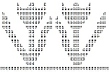 | 40 | 29 cell adjustment:  Landscape on short paper
Turkey for Dinner | 36 | Cannot be accommodated
Turkey 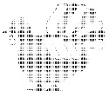 | 37 | Cannot be accommodated
Two Doves | 22 | none needed
Witch 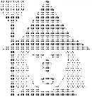 | 37 | Cannot be accommodated
Yoda | 39 | 29 cell adjustment:  Landscape on short paper

