Making a Simple Switch Accessible
Power Point Talking Book
Office 2007 and 2010

Your computer may look different depending your version of windows. This tutorial is based on Office 2007 which has the “ribbon,” but you may be able to follow it with different versions of MS Office. I do have this tutorial for previous versions, you can email me to obtain copies.

You’ll need:
- Digital photos
- A computer
- A computer microphone.
- Microsoft PowerPoint 2007
- Don Johnston Switch Interface Pro or similar product
- A switch made for use by people with disabilities (See Ablenet, Enabling Devices, TASH, Infogrip, etc.)
- The ability to burn copies of your presentation on a CD or Flash Drive

1. Get some photos in digital format.
How?
- Have photos from a regular camera put on a CD when you get the film processed
- Use a digital camera

2. Put them in your computer.

3. Getting Started.
Open PowerPoint. PowerPoint will prompt you to choose a format:

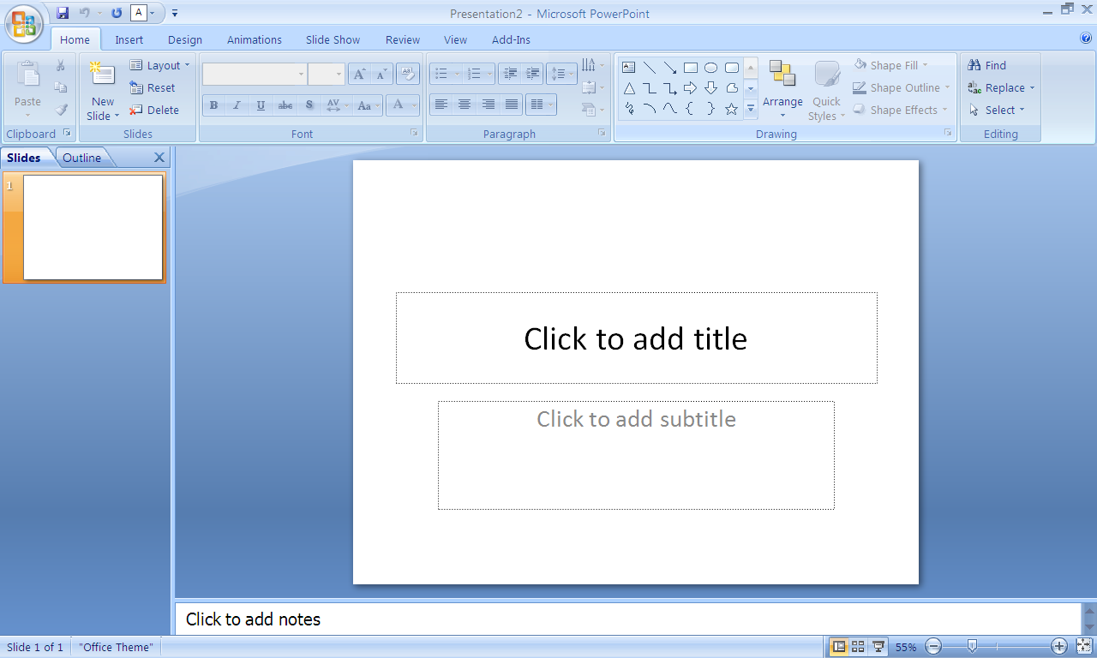

The first format in the list is a title page. If you wish to choose a different page style, select layout from the home page tab.

- Inserting Text.
Click in the text box and write the title of your book.
To move the text box, click the edge of your text box until the four way arrow shows. Then click and drag the box to the place on the page that you want it.

5. Choose the font style by highlighting the text and clicking on the font box in the toolbar in the Home tab and choosing the font you want. You may also change the font size by selecting your choice in the box next to it.
I like to use Arial or Arial Black because it is easy to read.

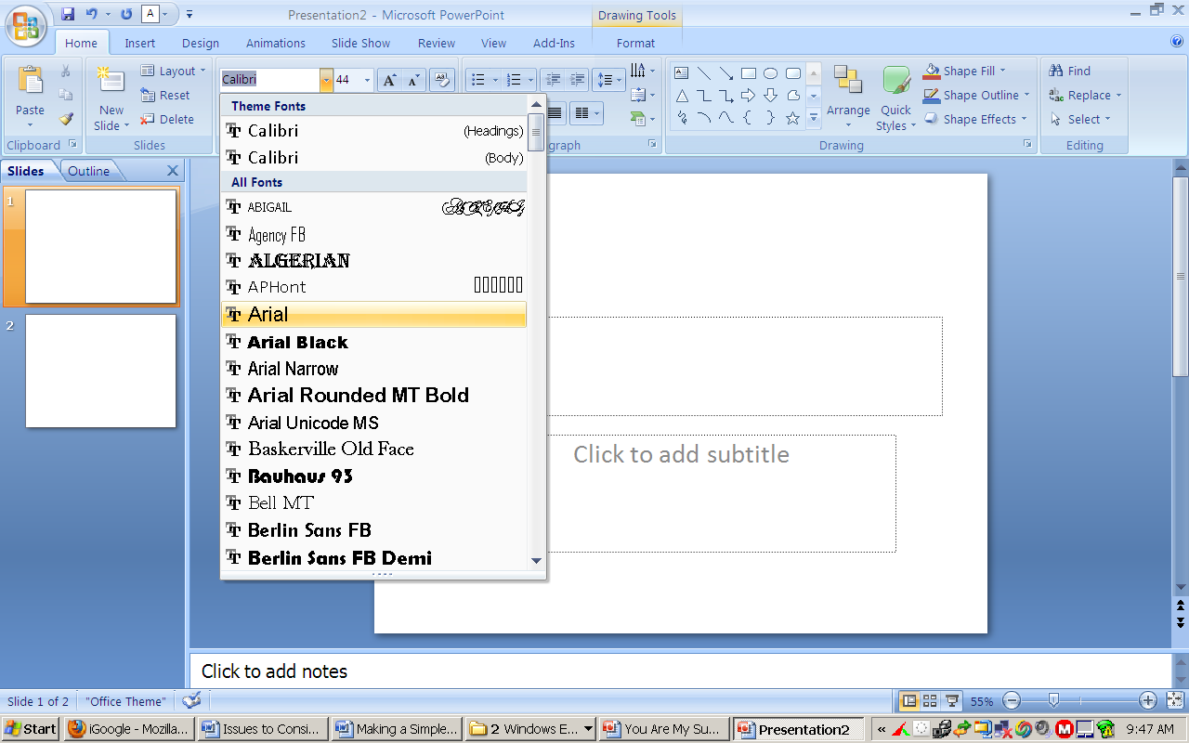

6. Font Color.
You can change the font color by selecting the down arrow next to the underlined “A” in the font group. The text must be highlighted in order to change the size, font or color!

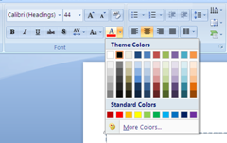

Click on “More Font Colors” to choose other colors.

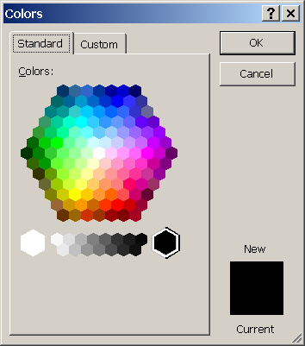
I’m going to use white, so I select that.

- Background color. To change the background color, select the Design tab on the ribbon. Select the Backgrounds group.

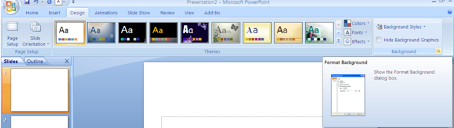

The Format Backgrounds dialog box will open. Select “color” and choose the color background you desire.

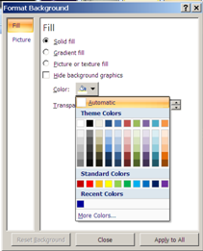

Select “Apply to All” if you want the background color on all slides in your book to be the same color. It is a good practice to use the same background color for all slides in a PowerPoint book.

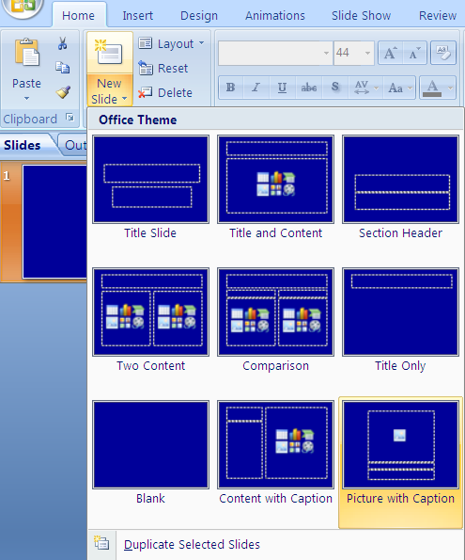
- Add More Pages. Return to the Home tab, select “New Slide” from the Slides group. Select a slide format you desire. In this case I’m choosing the one labeled “Picture with Caption.”

Follow the previous steps for changing the color of the font in the text box.

If you wish to keep your slide format the same throughout the “book,” you may choose to duplicate the desired slide by selecting the “New Slide” button and a moving down to the menu at the bottom of the dialog box. Select “Duplicate Selected Slide.”

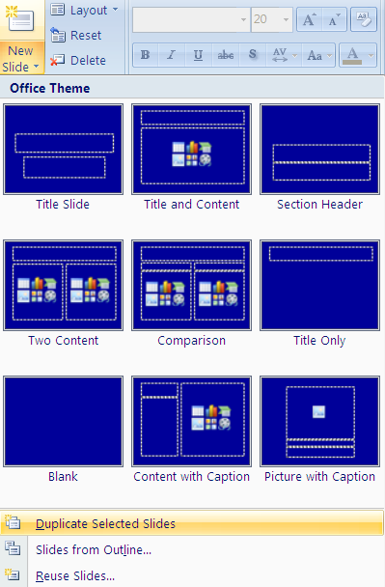

On the new page, type in the text you want for the next page of your book into the text box.

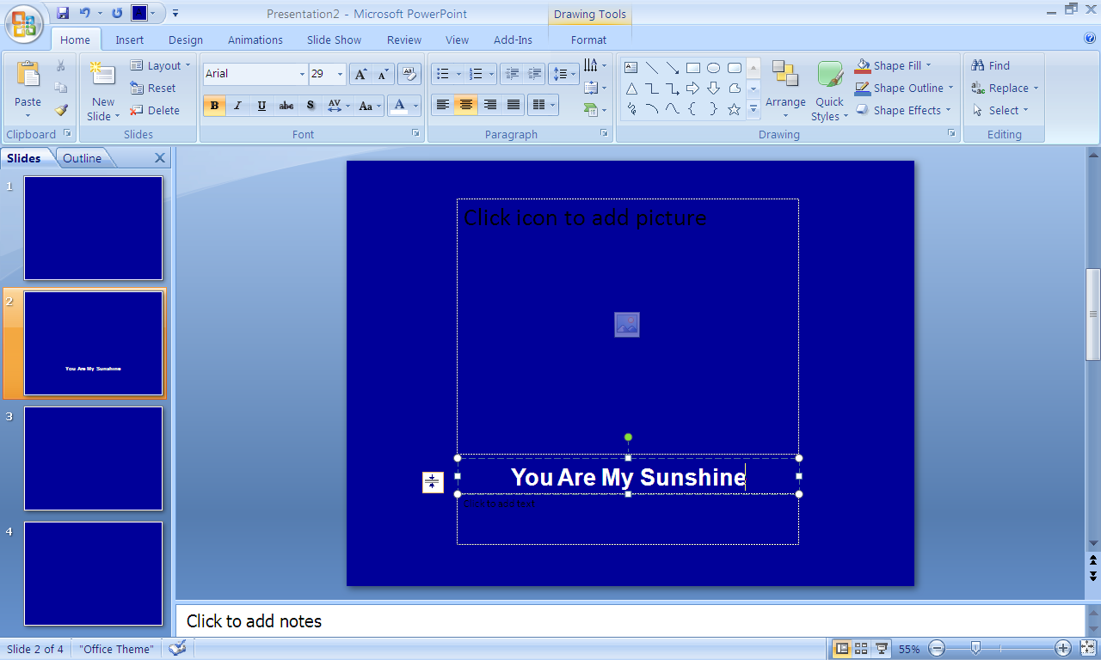

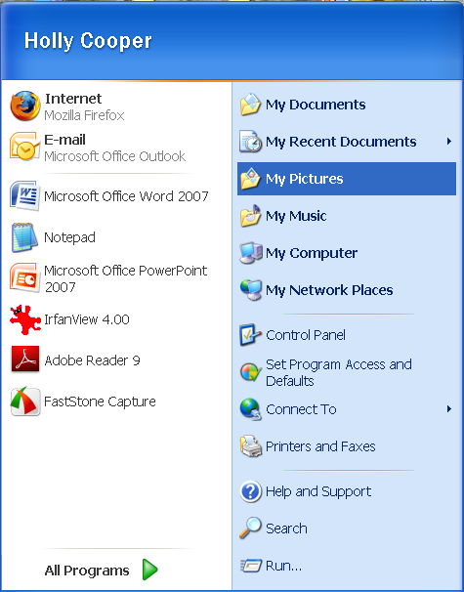
10. Adding Photos
To add photos to your book, you must first know where they are in your computer. Are they on a CD? Are they saved in My Photos? Save your PowerPoint presentation and minimize your PowerPoint window, then from your start menu, locate the file containing your photos.

If they are on a CD, select “My Computer” from the start menu and click on the CD icon.
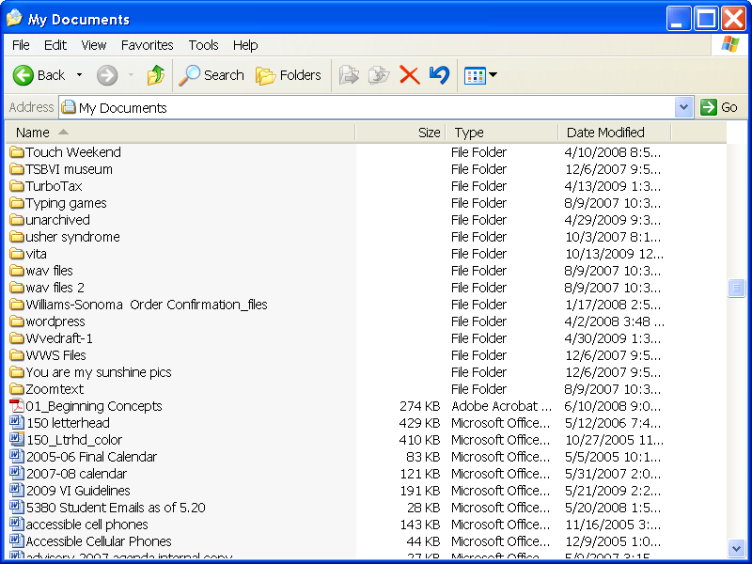
I usually make a folder on my desktop named the title of the book, and copy and paste only the photos I want to use in the book into that folder.

It’s a good idea to change the name of the photo to a meaningful name instead of a number by clicking on the number to highlight it, then typing in a word or two.

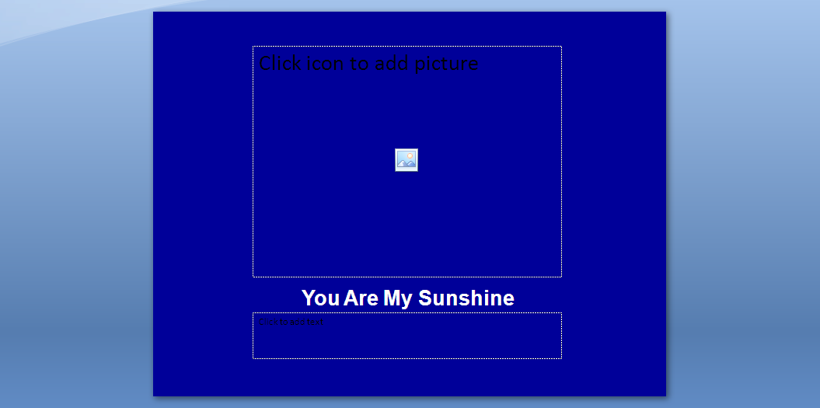
Inserting a photo.
To add a photo to your PowerPoint select the icon in the center of the photo box.

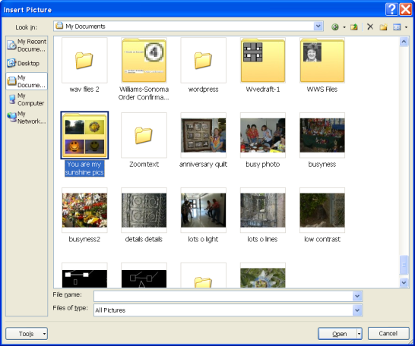
A dialog box will open. Go to the location where your photos are, highlight the one you want to insert, select it, then select insert at the bottom of the dialog box.

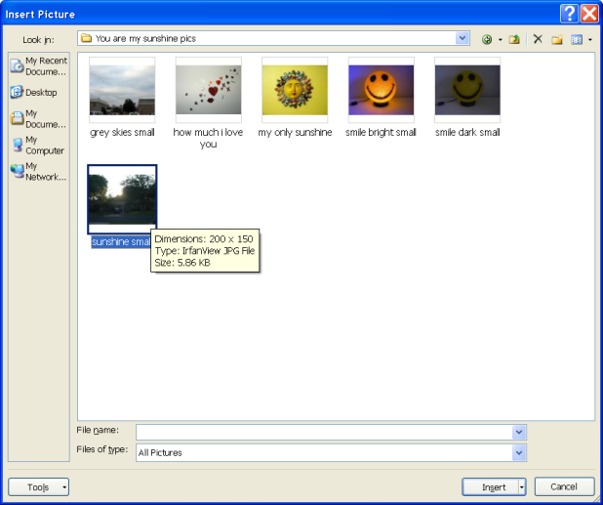

The photo will appear on the page of your PowerPoint.

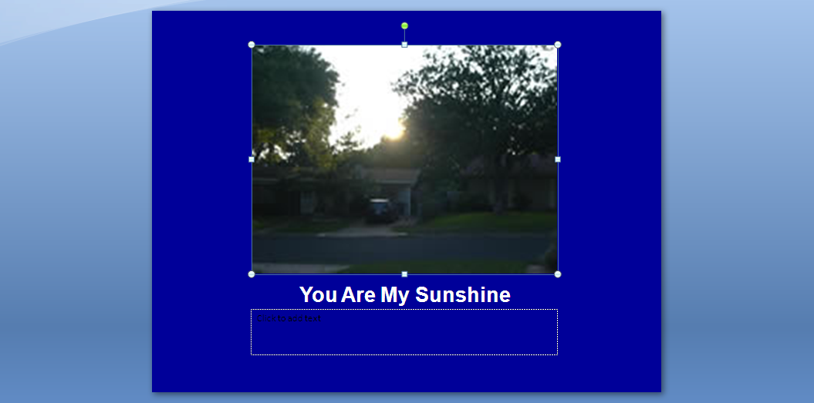

11. Inserting sound.
You must have a computer microphone to record sounds into your computer. You purchase one from a computer store or office supply store for less than $20. Some computers have built-in microphones.

To add sound, from the Insert tab in the PowerPoint ribbon. Select “Movies and Sounds” then “Record Sounds”.

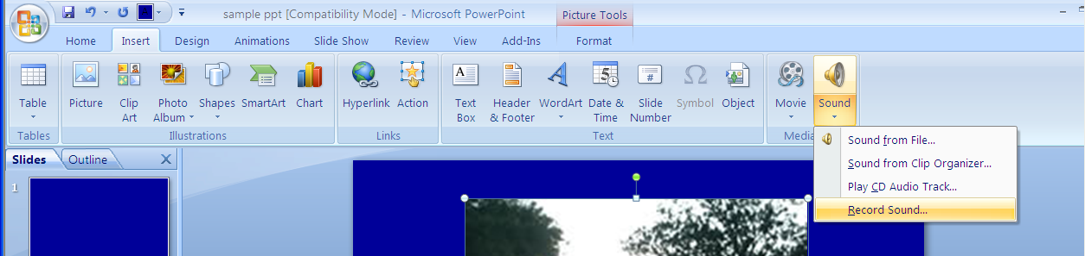

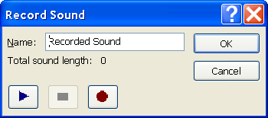
A dialog box will appear that looks something like the controls on a sound recorder.

Select the red circle to record.
Read or sing your text. Select the blue square to stop recording.

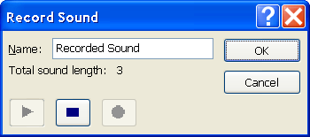
Select the blue arrow to hear what you recorded. If you don’t like it, you must click on cancel and start over with the insert menu. If you hit record again, you will add on to the recording you already made, you will not “tape over” it.

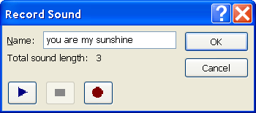
Next, give the sound file a distinct and meaningful name that you can remember, such as the first few words of the text.

Then select “OK”.

A small speaker will appear right in the middle of your slide. Move this off to the corner of the photo so it won’t be in the way.

If you want to change the sound, click to highlight the speaker and hit delete. Start over from the Insert menu.

You can avoid having to record your own sound by using a free program which adds digital speech to read the text in your PowerPoint. This program is called PowerTalk and works with PowerPoint 2000 and later. Download it here: http://fullmeasure.co.uk/PowerTalk/

12. Making the Sound Switch Accessible.
If we were making a PowerPoint Talking Book for a mouse or touch window user, we could insert arrows on each page for forward and back, and make the speaker icon larger so the user could click to hear the text as many times as she wanted. Instructions for making books with these features and more can be found at the ATTO Buffalo web site:
http://atto.buffalo.edu/registered/Tutorials/talkingBooks/powerpoint.php

For our students who are using switches, we want the sound to play as soon as the new slide shows because hitting a switch will only advance slides, not activate any other feature of PowerPoint.

If using Office 2007, on the ribbon, select the Animations tab. From the “Transitions” group, select “transition sound”

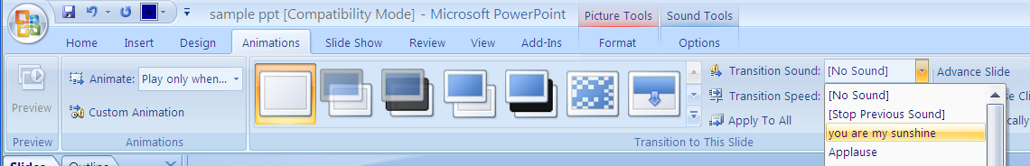

From the pull down menu select the title of the sound file you just made. In my case it’s “you are my sunshine”

In Office 2010 select the speaker on the slide display.

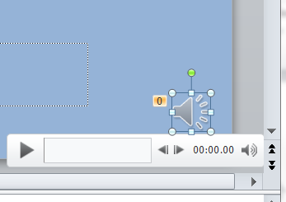

The “Audio Tools: Playback” tab will then allow you to choose the sound to play “automatically”.

Don’t click on “Apply” yet! We’re going to do one more thing…

13. Turning the Pages.
Make the page change animated to draw the viewer’s attention to the fact that the page changed.

In Office 2007, to do this, while still in the “Animations” tab, select the down arrow with the line above it to see all built-in choices available for the slide transition.

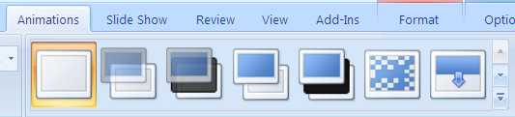

I usually use “Cover Left” which slides from the right to left. Sometimes, I use “Cover Down” which slides from the top down.

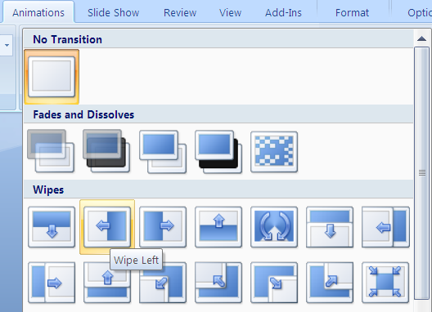

Click on “Apply To All” when you’ve decided.

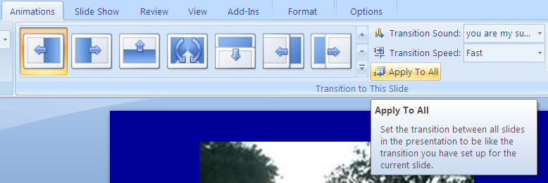

In Office 2010 these features are under the “Transitions” tab.

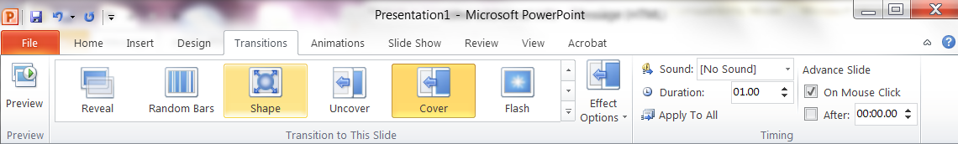

14. Repeat these steps with the new text, photo, sound and transition for each page.

In Office 2010, you can select “apply to all” for the transition animation.

15. Finishing up.
Return to your pages such as the title page that have text only and record your sound and set your slide transition for those pages as well.
Add an ending page and put a message such as “the end” or “let’s do it again”.

If you want the book to repeat itself as long as the child will interact with it, go to the “Slide Show” and select “Set Up Show”

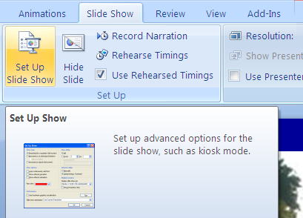

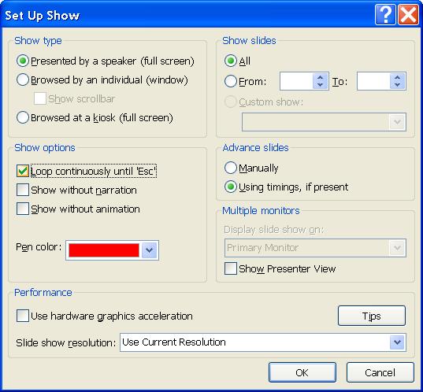
Select “Loop continuously until ‘Esc’”. Then select “OK”.
This will make the slide show repeat until you press the escape key.

16. Using Your Book
To use your book, save it to a CD or other storage media device that will hold the large file size. If the computer in the classroom where it will be used doesn’t have PowerPoint, you can download a free viewer from the Microsoft website and burn it on the CD also. Microsoft has made this a free service and gives permission to copy and distribute PowerPoint Viewer.

Plug in your switch interface and switch. Start PowerPoint and run the talking book using the switch. You can also print a full page copy on paper and have it available as a standard book to use in the classroom.

Be creative for your students! Enlist the help of peers to take photos and speak the text. Make simple books with friends or family members saying hi, singing a song, or showing some of their favorite things to do. Make books of your field trips, special events, and everyday events. PowerPoint and similar presentation software allows us to create age appropriate books targeted to the interests of the individual students.

Have fun! As you gain experience the process will become faster.

