Music Note Braille

Letters- K, Y, C, H,O, Q, U and W

Created By: Samantha Zauner



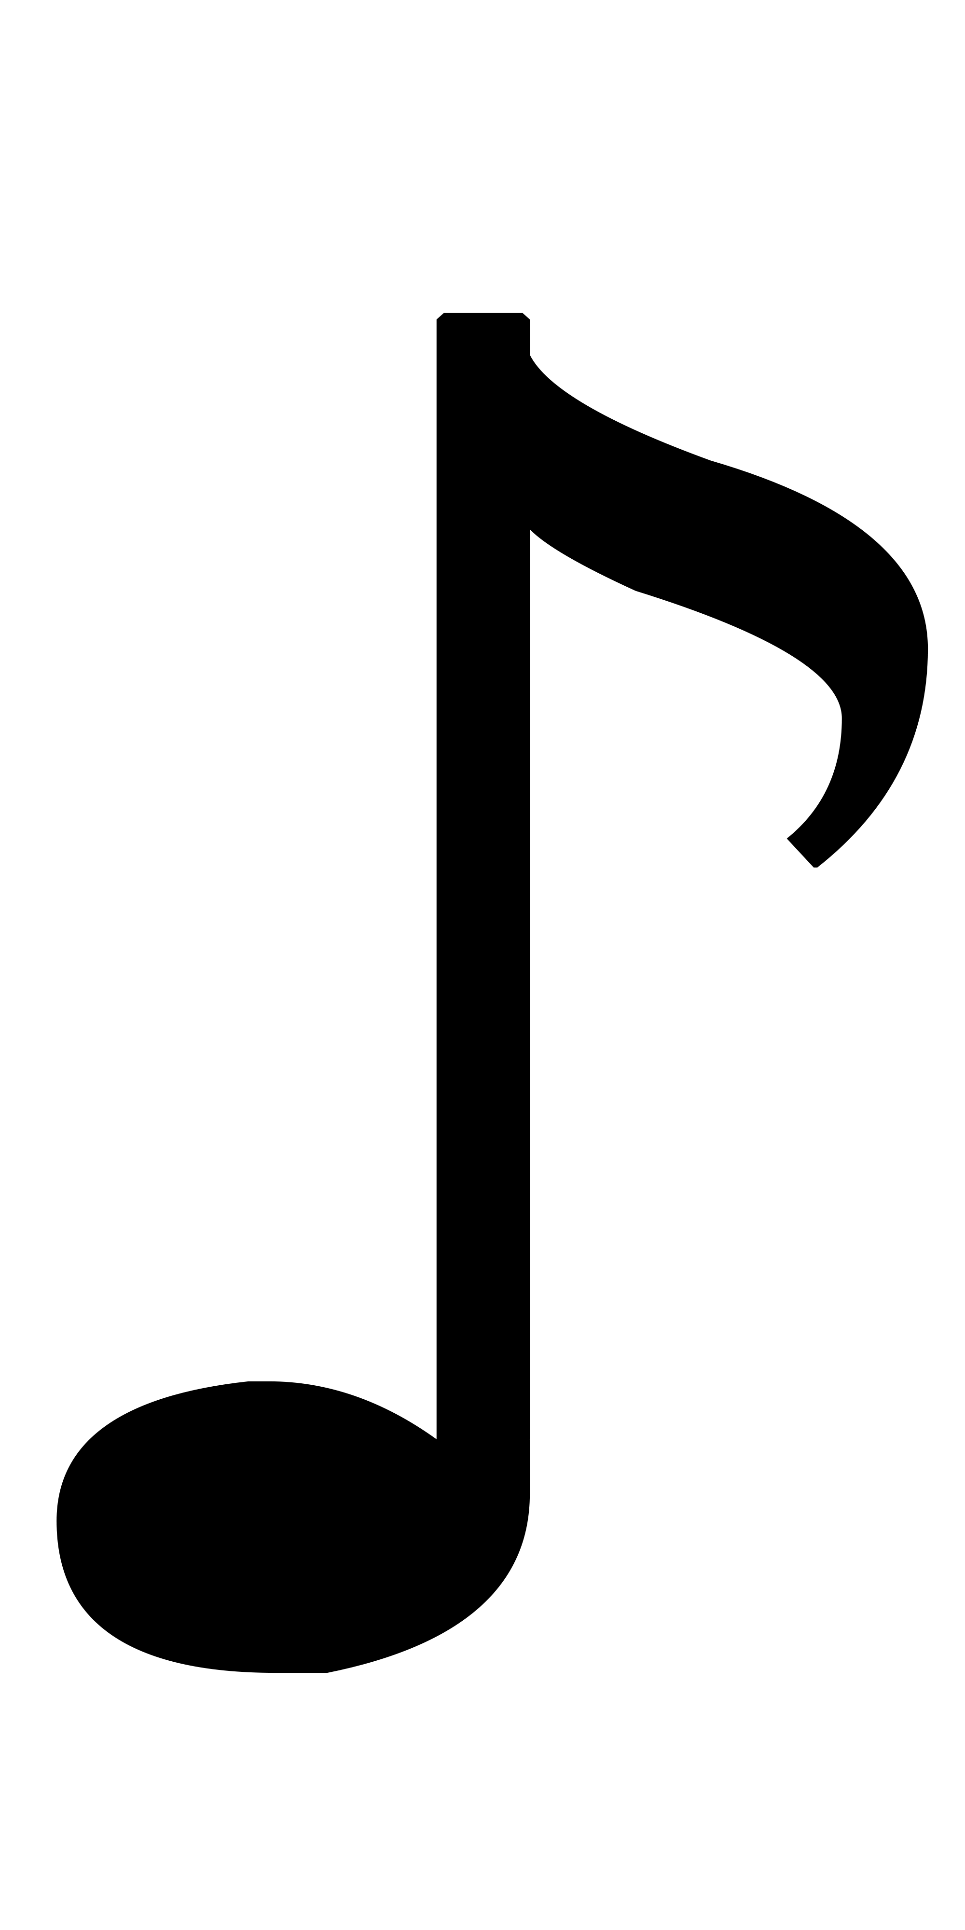

**Dot 1 and 3**

**Dot 1, 3 and 5**





**Dot 1 and 4**

**Dot 1, 2 and 5**

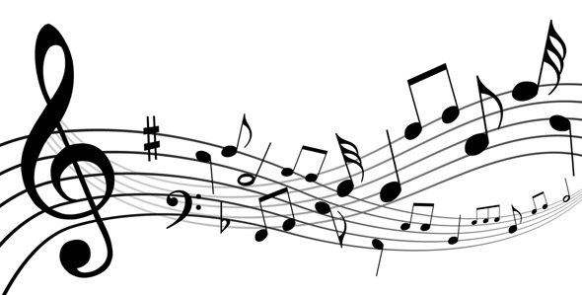



**Dot 1, 3, 4, 5 and 6**

**Dot 1, 2, 3, 4 and 5**





**Dot 2, 4, 5 and 6**

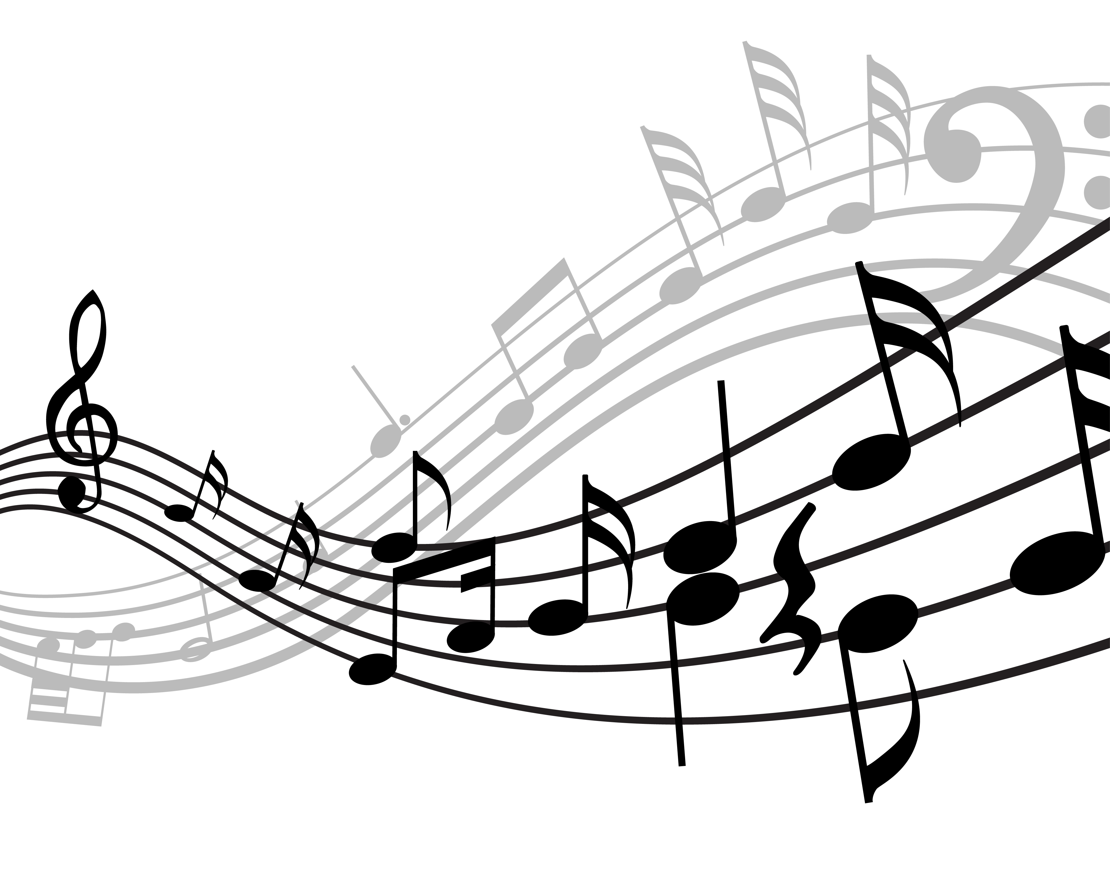

**Dot 1, 3 and 6**

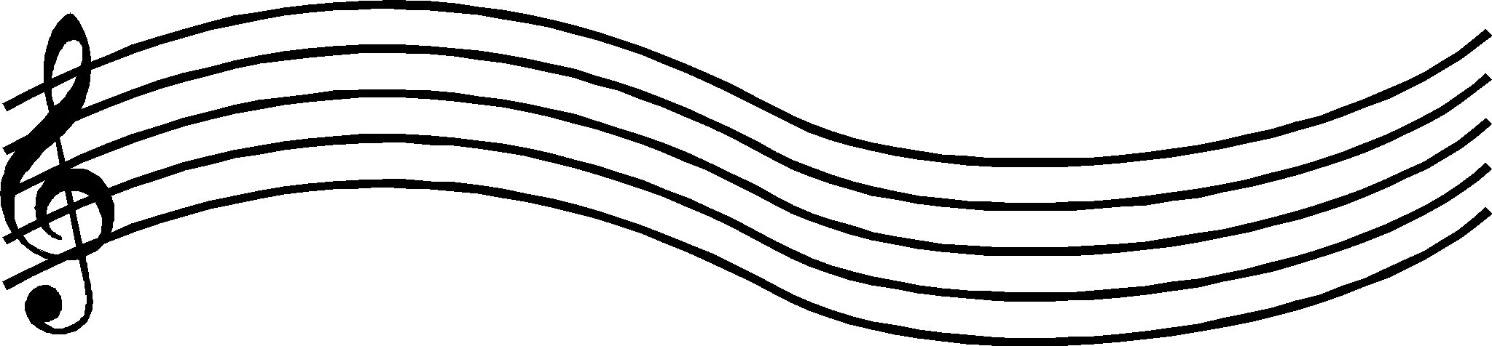

**K**



**W**

**Y**

**C?**





**H**



**OK**



**Q**





**U**









