Reflecting on Instruction: Butt Heads

Six Essential Components |  | Examples of 6 essentials observed in video of activity | Reflection notes to adjust Instruction
 | - Builds on student’s strengths and interest, opportunity for choice-making | K had a fascination with repeated phrases and specific actions, like “butting heads”  I wanted us to start with something she loved and to give her what she wanted and turn it into a simple story.  K does not have a great deal of expressive language choices so we need to start with something silly and easy for her to talk about in a playful way. | K does show that she is challenged sometimes by the activity.  She said: “Good job playing with Miss Amy” (which was directed to her mom- seeking acknowledgement from her that she was doing what she was supposed to do).  Often I think that people with communication challenges need confirmation when they are trying something new.
 | - Includes peers in the interaction | K’s mom was observing and sometimes participated in our play. We were gathering ideas that she could use at home and on play dates. | We are just meeting each other to play and so Connor is introduced. I could have included her mother too!
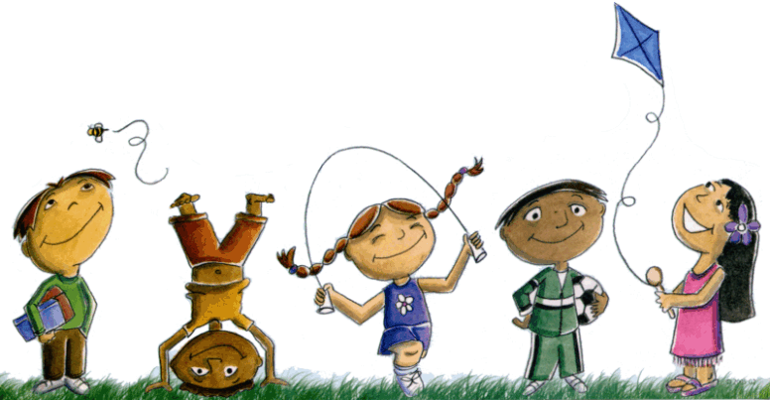 | - Creates an atmosphere of play (social and/or symbolic) with modeling and encouragement | We used the “writing wall” – paper on the wall, so she could move freely and change positions. She frequently needed to jump. She could get close to the wall and to me. She could touch the letters. | I want her to be aware of the space in the room and to use movement to make choices physically and not only with words. I want her to move things around dynamically.
 | - Provides a context for activity through predictable routines, consistent and accessible locations, adequate space for enactment and story creation | We were playing in a classroom but wanted something that could be adapted easily to home. We used simple things like high contrast markers. Index cards which could move to the seat of a chair or the floor.
 | - Includes the use of props and actions and physical enactment | We use a giant stuffed animal, an emperor penguin named Connor to join in our play of butting heads. Connor is large and soft. | We could easily allow her to start choosing from her own preferred items to add them to the story. This can be done later.
 | - Adult is flexible and supportive and provides scaffolding between highly directive and participatory role and non-directive encourager and scribe. | We are starting our relationship together and her mother is supporting our engagement and play. | I am a little too directive sometimes. I should have picked up on her clever joke about including “nothing” in the story.  I do know she loves music from a conversation with her mother and so we start to sing our story a bit to add interest.

