Texas School for the Blind and Visually Impaired
Outreach Programs
www.tsbvi.edu | 512-454-8631| 1100 W. 45th St. | Austin, TX 78756

Playing with Words
June 25, 2020

Presented by
Linda Hagood, CCC-SLP,
Washington State School for the Blind
hagood.linda@gmail.com
Jay Hiller, CCC- SLP,
Texas School for the Blind & Visually Impaired
hillerj@tsbvi.edu
Megan Mogan, CCC-SLP, Deafblind Specialist,
Arizona Deafblind Project
megan.mogan@asdb.az.gov

Facilitated by
Charlotte Cushman, Perkins School for the Blind and
Kate Hurst and Cyral Miller, TSBVI Outreach Programs

Developed for
Texas School for the Blind & Visually Impaired
Outreach Programs

Power Point Slides

Slide 1
Texas School for the Blind & Visually Impaired
Outreach Programs presents Playing with Words
Presented by
- Linda Hagood, CCC-SLP, Washington State School for the Blind
- Jay Hiller, CCC- SLP, Texas School for the Blind & Visually Impaired
- Megan Mogan, CCC-SLP, Deafblind Specialist, Arizona Deafblind Project
Facilitated by
- Charlotte Cushman, Perkins School for the Blind and
- Kate Hurst and Cyral Miller, TSBVI Outreach Programs

Slide 2 What is Playing with Words?
- A collaborative process of co-creation of stories with students who are blind or visually impaired including those with additional disabilities
- Focuses on expanding spoken or sign-based communication, and increasing self-determination, self-regulation, and creativity rather than a perfectly composed story.
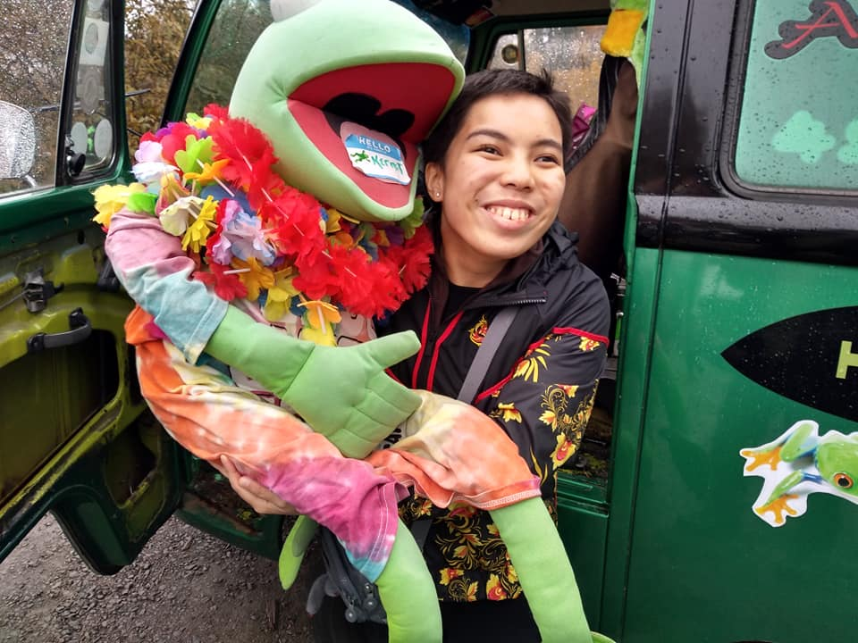
Figure 1 Young woman holding a large Kermit stuffed toy.

Slide 3: Who Created Playing with Words?
- Linda Hagood, Speech-Language Pathologist
- Works extensively with students who are blind or visually impaired with additional disabilities at Washington State School for the Blind and TSBVI
- Also worked with sighted children with autism and multiple disabilities
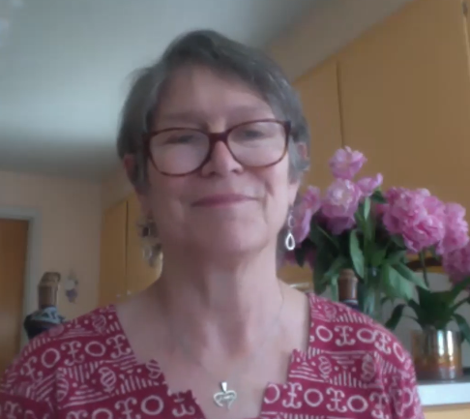
Figure 2 Linda Hagood

Slide 4: Linda’s Goal
- Longer episodes of play and interactions and balanced conversation with students
- Engagement with peers, family and others

Figure 3 A young boy dressed as Sheriff Woodie from Toy Story and a young girl dressed as the Queen of Arendelle from Frozen.

Slide 5: Development of Playing with Words
- Typical students often engage in story creation around play interests and interactions.
- Integrated play groups designed by Pamela Wolfberg San Francisco State University
- Accepting and validating the language of students with autism by putting it down on paper, their language and social interactions grew.

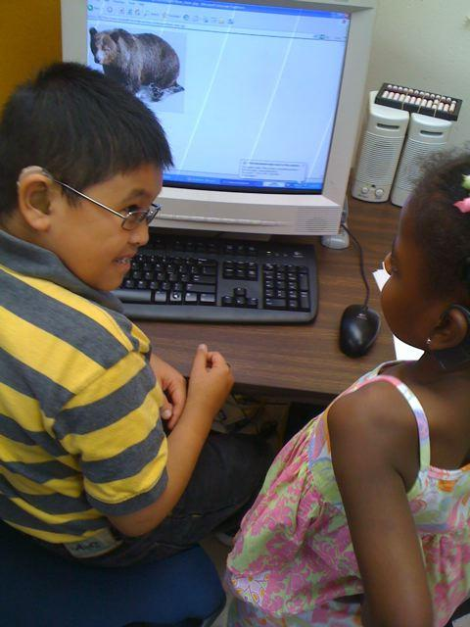
Figure 4 Two children who are deafblind converse with each other at a computer.

Slide 6: For Students who are Blind & VI
Playing with Words provides a way to blend and embed ECC and Common Core instruction.

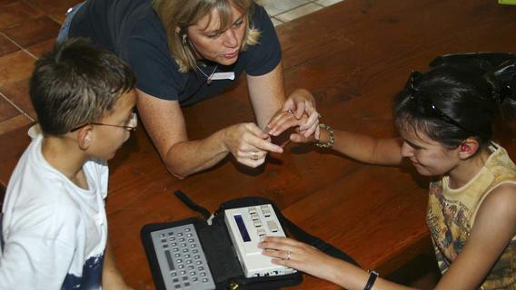
Figure 5 Two children who are deafblind converse with each other with the support of an intervener and braille devices.

Slide 7: Development of Language in VI
- Students with visual impairments tend to focus on words and sounds rather than objects or movement in language development.
- Words and sounds come first for many blind & visually impaired students.
- Play-based storytelling activities help the students incorporate objects and movement to develop shared meaning.

Slide 8: Playing with Words Microsite
- https://www.pathstoliteracy.org/playing-words
- Builds off early work in Better Together, “Writing Can be Child’s Play” (2008, TSBVI)
- Newest version based on experience and literature review found on Playing with Words microsite and included in Perkins course, Better Together, this summer.
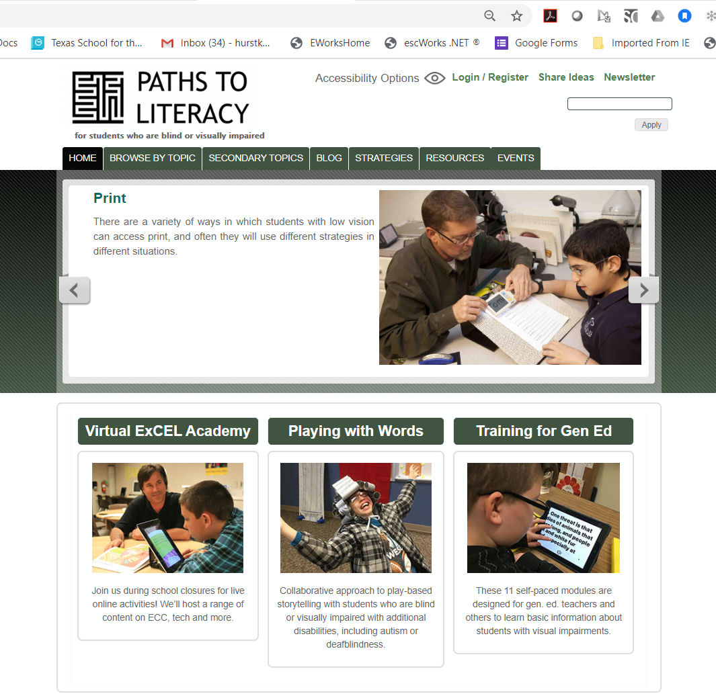
Figure 6 Screen shot of the Paths to Literacy Home page.

Slide 9: Shift from Writing to Oral Narratives
- Students who lack a foundation of being able to organize oral narratives often have difficulty organizing written narratives and having good conversations
- Co-creation of the story allows for both
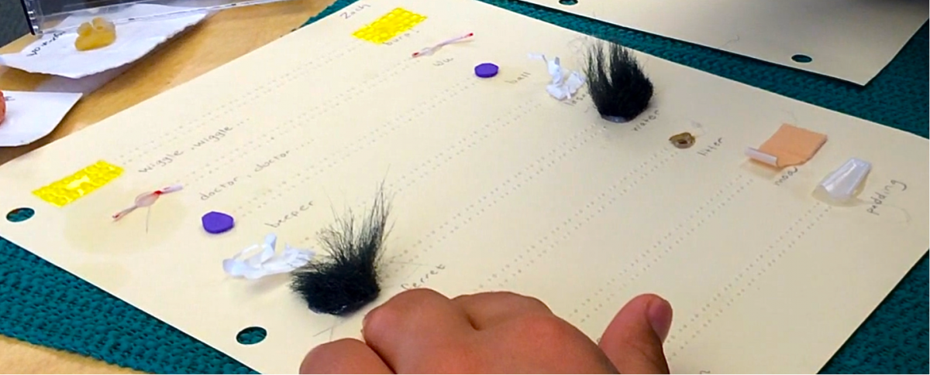
Figure 7 A child's hand explores a page of braille and corresponding tactile symbols.

Slide 10: Collaborators
- Linda Hagood, CCC-SLP, Washington State School for the Blind
- Jay Hiller, CCC- SLP, Texas School for the Blind & Visually Impaired
- Megan Mogan, CCC-SLP, Deafblind Specialist, Arizona Deafblind Project
Playing with Words Microsite on Paths to Literacy (Perkins & TSBVI)
- Charlotte Cushman, Perkins School for the Blind
- Kate Hurst, TSBVI Outreach Programs
- Cyral Miller, TSBVI Outreach Programs
The students who have shared their imaginative stories

Slide 11: Stephanie Face, TVI/Classroom Teacher
- Elementary Education Teacher
- TVI for 11 years at Washington State School for the Blind
- Self-contained middle school classroom
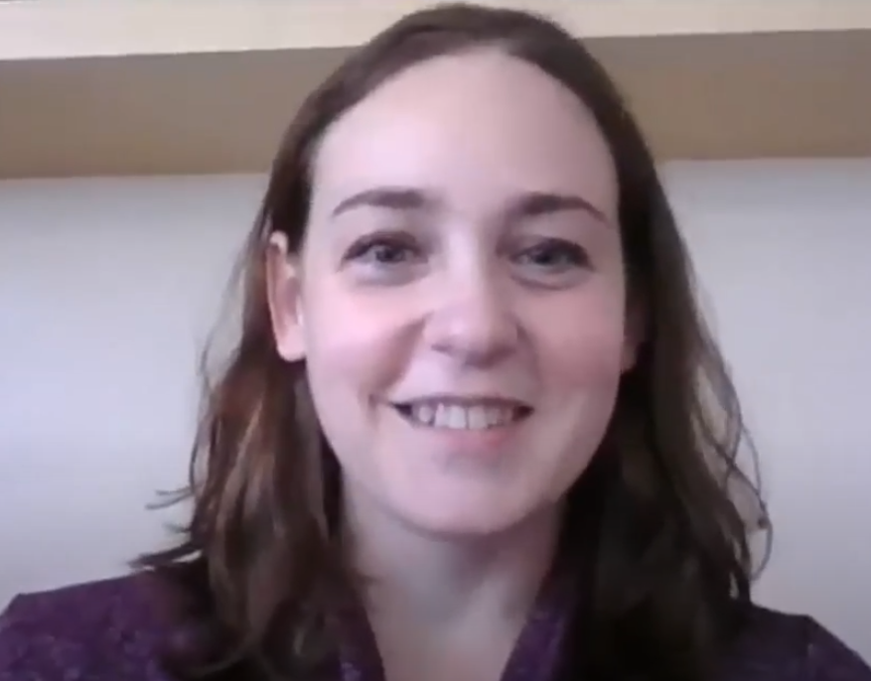
Figure 8 Stephanie Face.

Slide 12: Karmay Miller, Teaching Assistant
- Degree in Elementary Education
- Preschool Teacher
- Special Education Teaching Assistant
- Instructional Assistant at Washington State School for the Blind
- Works with students who have additional disabilities
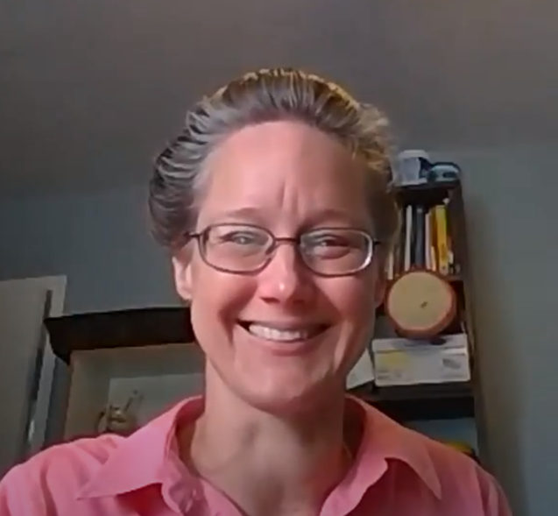
Figure 9 Karmay Miller

Slide 13: Types of “Stories”
- Experience Stories
- Songs & Poems
- Pretend Stories
- Yoga Stories
- Epic Stories
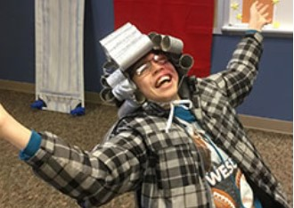
Figure 10 A young boy throws up his hands and laughs while wearing a hat made of toliet paper rolls.

Slide 14: Megan Mogan
- CCC-SLP
- Arizona State School for the Deaf and Blind, Tucson
- Deafblind Specialist, Arizona Deafblind Project
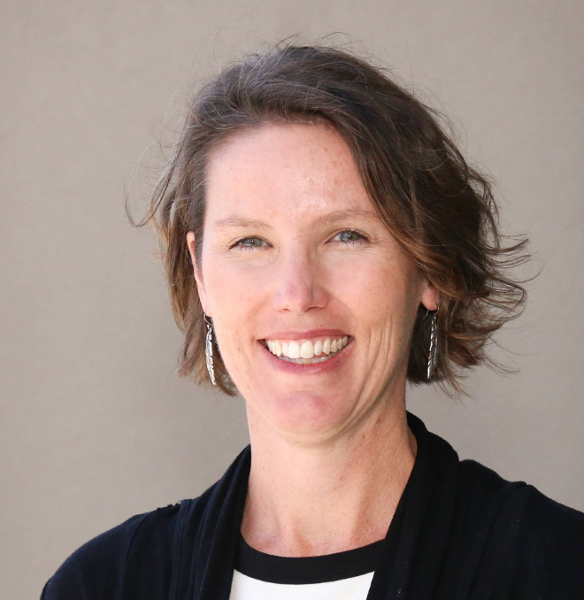
Figure 11 Megan Mogan

Slide 15: Experience Stories
Up
https://www.pathstoliteracy.org/playing-words/experience-stories/up-interactive-story-writing-process-prelingustic-student-who-deafblind
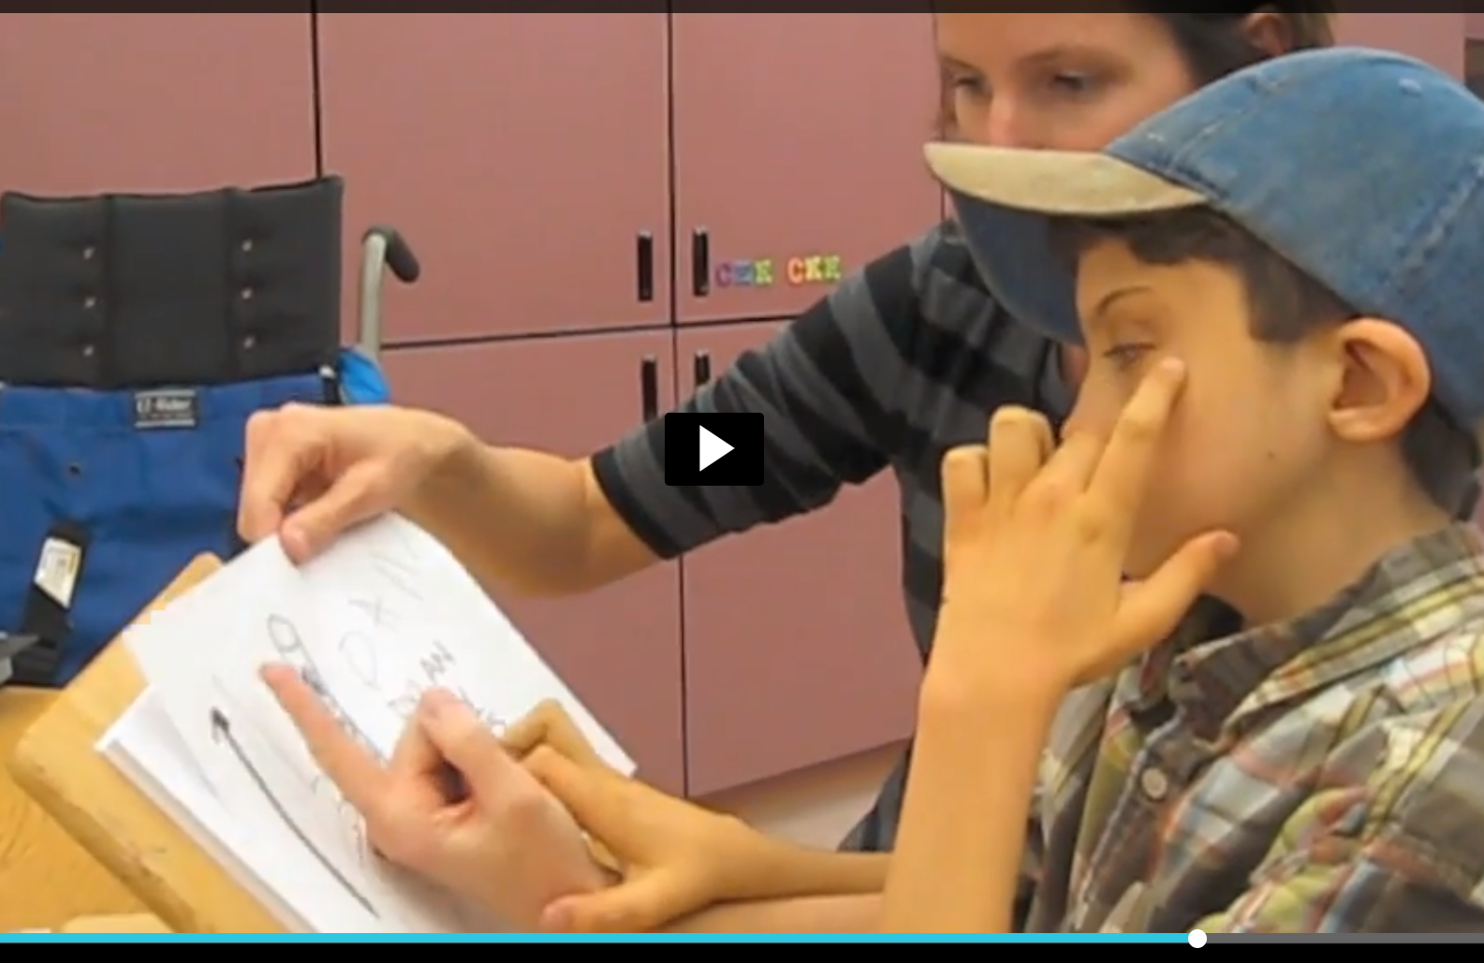
Figure 12 Screen shot of Megan and her student signing up from the video clip, "Up".

Slide 16: Songs and Poems
Snow
https://www.pathstoliteracy.org/playing-words/songs-poems/snow-poem

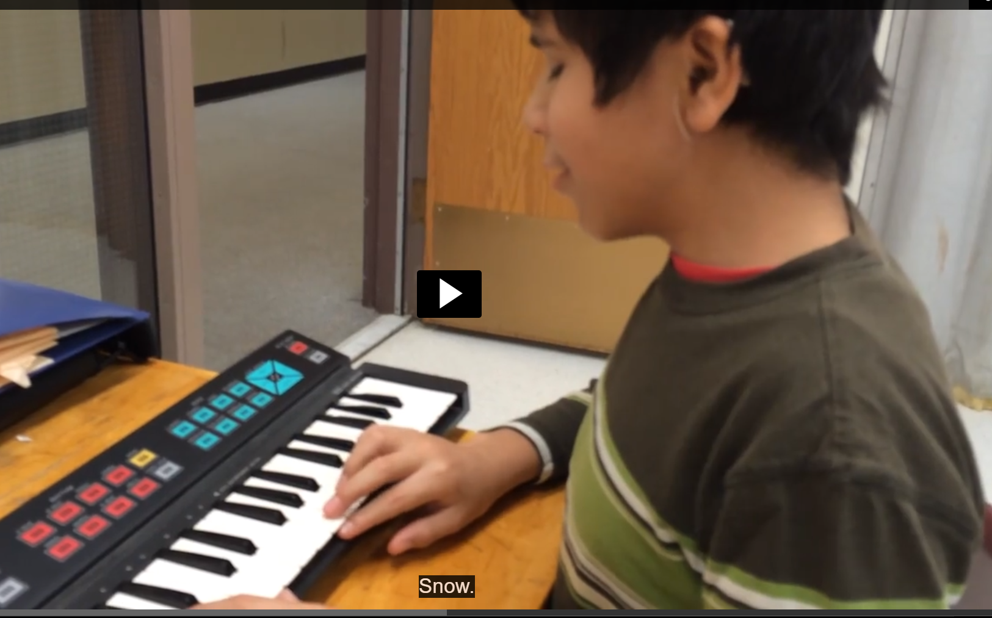
Figure 13 Screen shot of Angel from the "Snow".

Slide 17: Songs and Poems
Download the Snow Reflection Sheet
https://www.pathstoliteracy.org/sites/pathstoliteracy.perkinsdev1.org/files/Reflection_snow_poem.pdf
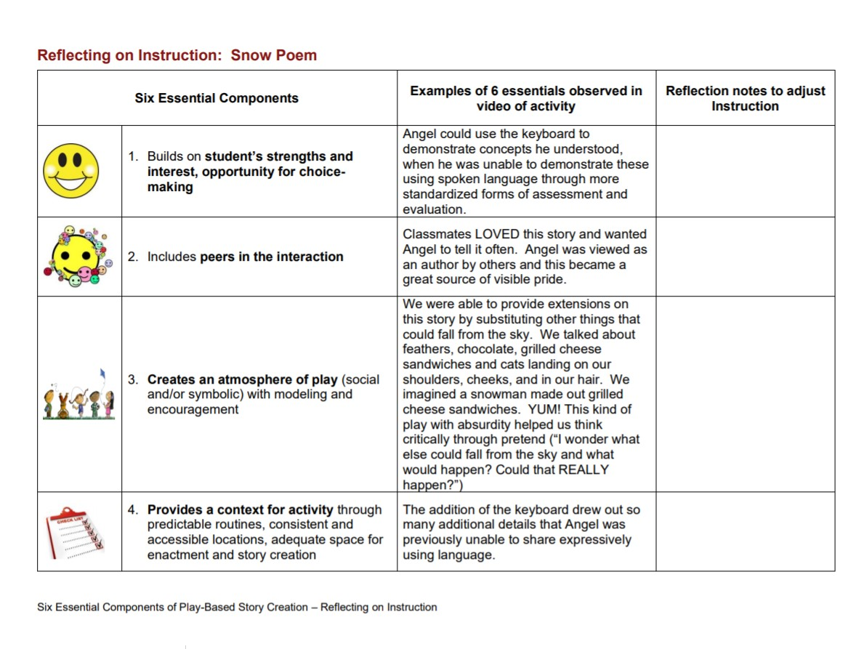
Figure 14 Image of the Reflection Sheet form from Playing with Words.

Slide 18: Linda Hagood
- CCC-SLP
- Washington State School for the Blind
- Developed Playing with Words approach
Figure 15 Linda Hagood

Slide 19: Pretend Stories
My Brain Is an Admiral Washer
https://www.pathstoliteracy.org/playing-words/pretend-stories/my-brain-admiral-washer

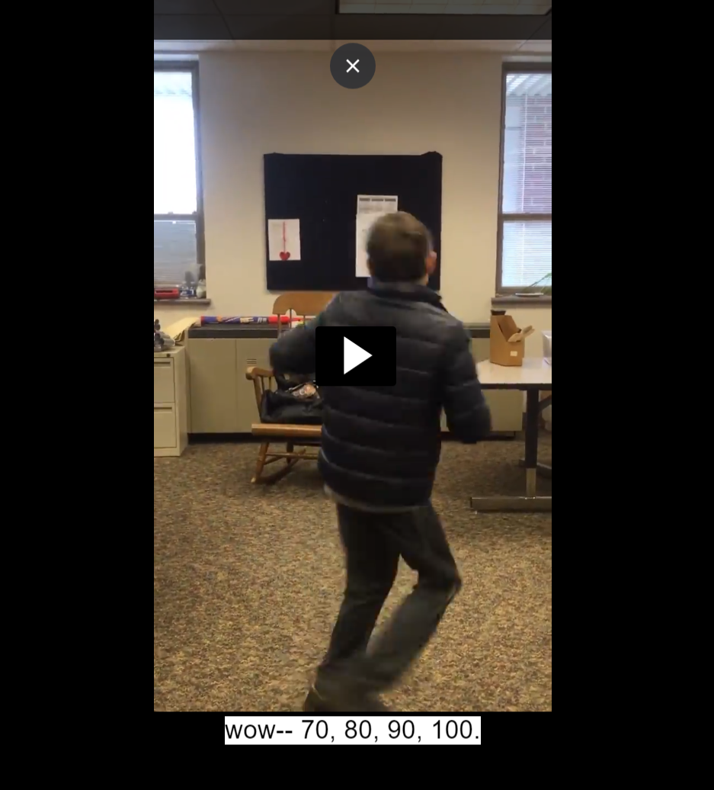
Figure 16 Screen shot from My Brain is an Admiral Washer

Slide 20: Yoga Stories
Forest Walk
http://www.pathstoliteracy.org/playing-words/yoga-stories/forest-walk-meditation
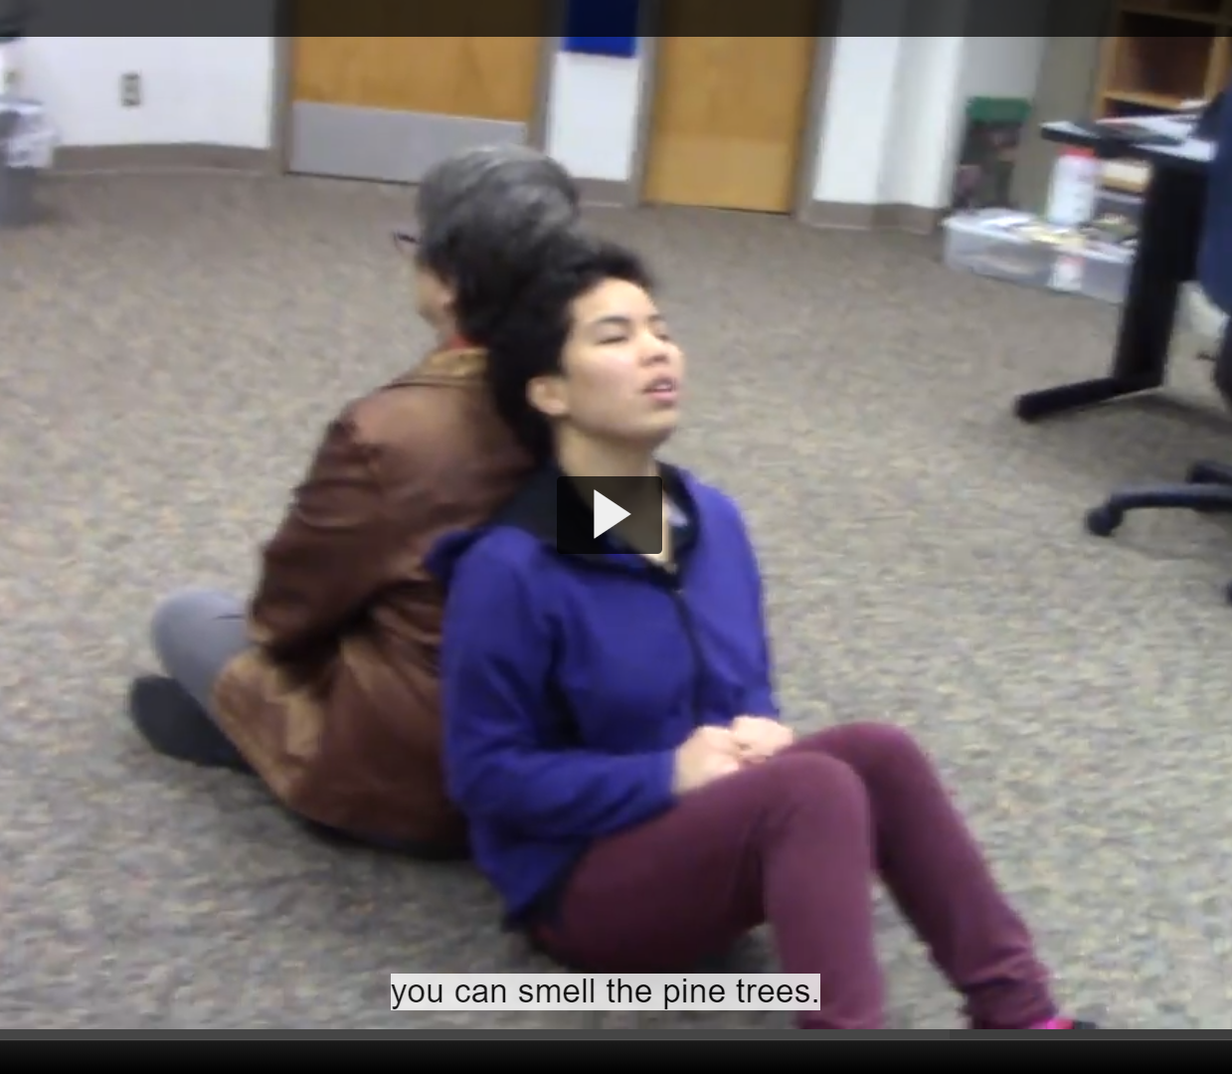
Figure 17 Screen shot of Forest Meditation from Playing with Words.

Slide 21: Jay Hiller
- CCC-SLP
- Texas School for the Blind & Visually Impaired
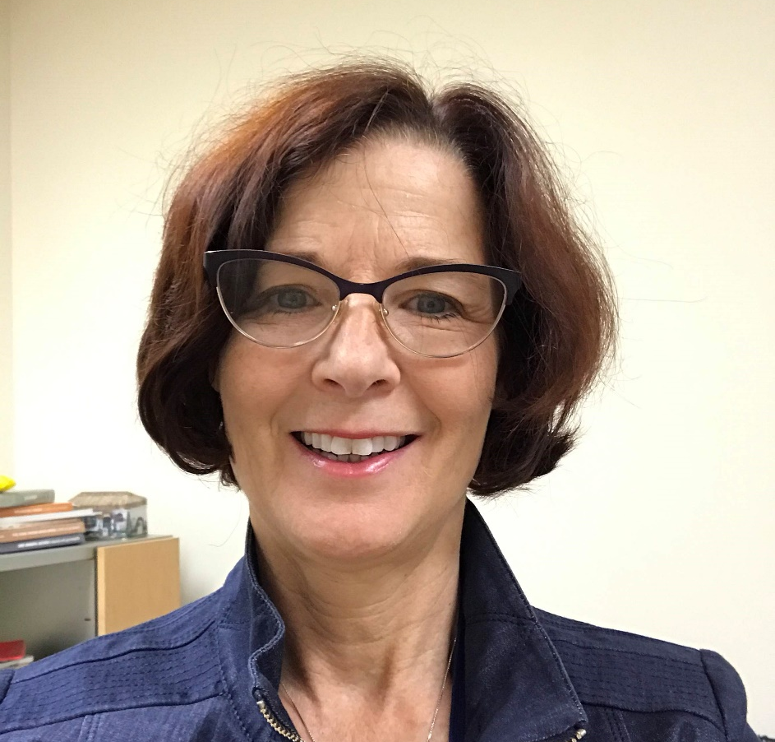
Figure 18 Jay Hiller

Slide 22: Benefits of the Approach
- Excellent medium for forming a relationship with students
- When more than one student is in the group, cultures develop around the epic stories
- Provide a strong medium for both targeted goals and other linguistic needs that come up as you’re working
- Not judgmental “Yes and…” versus “Not quite”
- Doesn’t require a lot from the therapist in terms of preparation

Slide 23: Epic Stories
Dogman Stories
https://www.pathstoliteracy.org/playing-words/epic-stories/dog-man-story
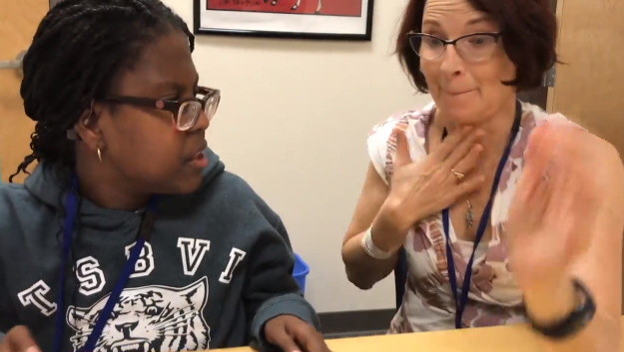
Figure 19 Screen shot of Gabby and Jay from Dogman on Playing with Words.

Slide 24: Epic Stories
- Epic stories just happen
- Process, not the final product, is what is important
- Student’s interests lead to high motivation
- Allow for the focus on various goals such as:
  - perspective taking
  - emotions
  - academic vocabulary
  - linguistic devices to negotiate with peers
Figure 20 Book cover of Dogman by Dav Pilkey.

Slide 25: Inclusion of Peers
- Include peers with different conversational abilities and challenges
- Peers allow adults to step back and let peer interactions take place
- Works well in the new “Zoom” world of instruction
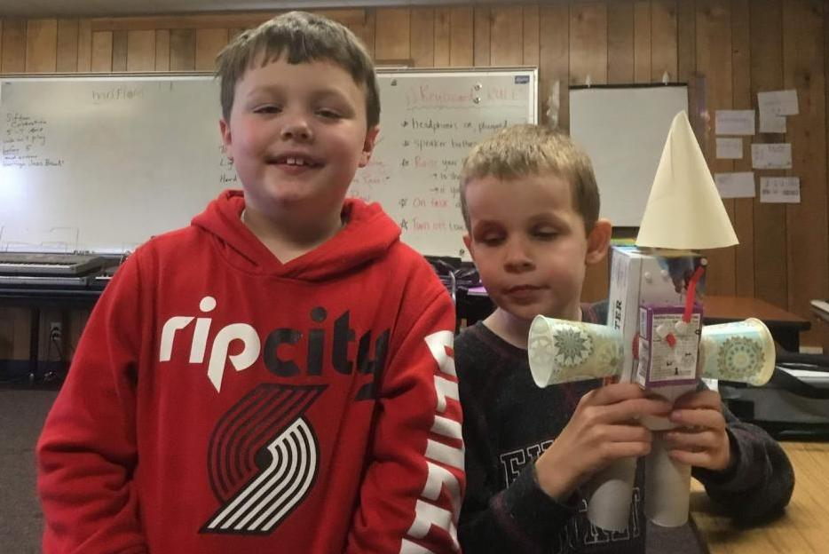
Figure 21 Two young boys. The boy on the right holds a "robot" made from paper cups. Image from Two Boys and a Robot on Playing with Words.

Slide 26: Process versus Product

Process-based Instruction
- Allows for targeted goals; goals can shift from day to day or within a lesson
- “Yes and” offers student opportunities to actively participate and try different responses
- Teacher can introduce response using the perspective of another character

Product-based Instruction
- Teacher created with little or no input from student
- Student is passive
- Specific target for learning does not allow for student driven learning

Slide 27: Six Essential Components
- Build on all students’ strengths and interests; choice-making
- Include peers in intervention sessions
- Build atmosphere of play, with modeling and encouragement of varying levels of social play and symbolic dimensions of play
- Contexts for activity include predictable routines, consistent, accessible locations, adequate space for enactment and story creation
- Adult role is to be flexible and supportive, acknowledging, accepting and expanding on participant input, scaffolding between highly directive, highly participatory role and non-directive encourager and scribe
- Physical enactment, including the use of props and actions, should be included in all intervention sessions

Slide 28: Playing with Words Microsite
Can be accessed from the Home page of Paths to Literacy or by going to https://www.pathstoliteracy.org/playing-words
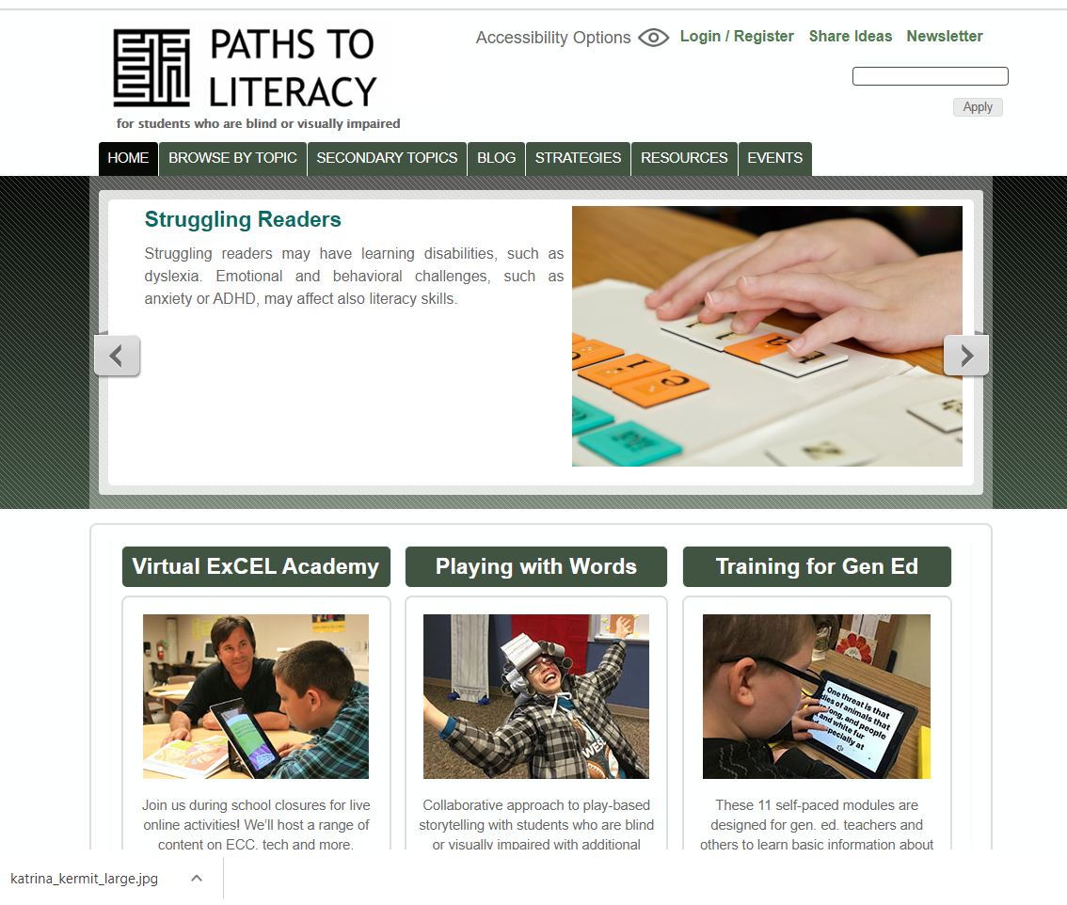
Figure 22 Playing with Words microsite on the Paths to Literacy website.

Slide 29: Map
https://www.pathstoliteracy.org/playing-words/site-map
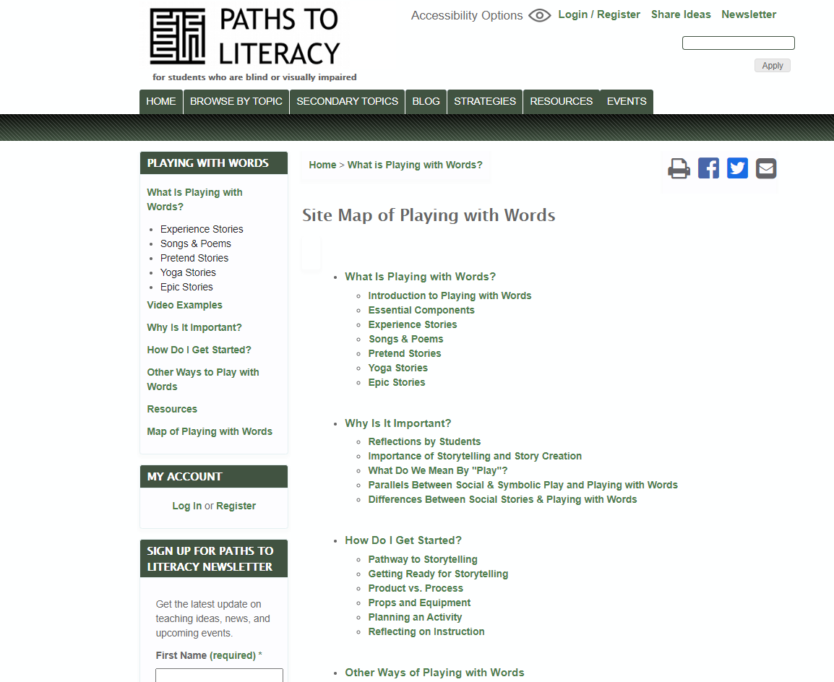
Figure 23 Screen shot of "Map" of the Playing with Words microsite.

Slide 30: Plan and Reflect
Website provides guidance and forms to help you get started.
Go to https://www.pathstoliteracy.org/playing-words/how-do-i-get-started
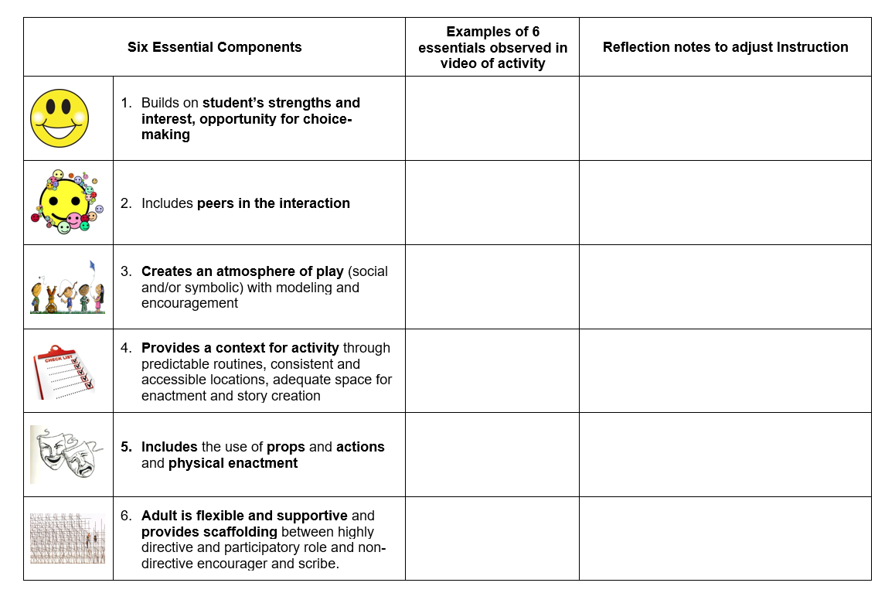
Figure 24 Planning Form from Playing with Words microsite.

Slide 31: Props
https://www.pathstoliteracy.org/playing-words/how-do-i-get-started/props-and-enactment
- Put together a box of props that can be used to support creative storytelling - NOT miniatures
- Find out what the student likes first, and also to choose items that are flexible.
- Get props and suitcases from thrift stores or garage sales to put props in
  - Blocks
  - Chime & Mallet (for chime)
  - Masks (generic)
  - Hats
  - Scarf/piece of cloth
  - String
  - Muffin cup liner/foil
  - Play-doh or clay
  - Hand mirror
  - Headband with pipe cleaners attached
  - Boxes of various sizes
  - Silverware, bowl, cup, napkin
  - Hand puppets, including generic puppets (e.g. or oven mitt, eyeglass cases that can open and close to make them "talk")
  - Rug or yoga mat to mark off space (e.g., create a road/river)
  - Foam rockets.
  - Step stool or step ladder (to help them be "giants" or to walk up a mountain)
  - Duck Tape (always comes in handy)

Slide 32: Video Examples
https://www.pathstoliteracy.org/playing-words/resources/video-examples
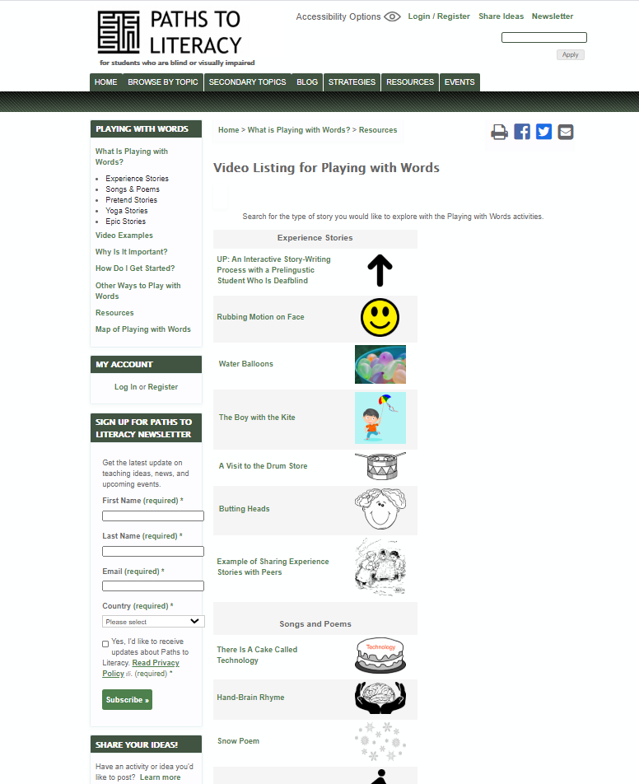
Figure 25 Screen shot of Video Examples from Playing with Words.

Slide 33: Questions? Comments?
Type your questions or comments in the chat To: All panelists and participants.

Sample of Product-Based Therapy

Used to Teach Social Language Goal

This activity was written as a home assignment for a student to complete during the pandemic. However, I’ve done this type of language story live in groups to stimulate class discussion too. It has its place. You can see the following features:
- Targets are static and discrete. Unlike a process-focused intervention such as playing with words, there’s no real opportunity for the student to change things or to demonstrate other areas where he would benefit from intervention.
- There are definite right and wrong answers. I gave this student feedback on his percent correct as part of the written assignment. If this had been done live, my response to off-target responses would have been “No, not quite…” as opposed to “Yes, and….” the response we use for all responses in Playing with Words.
- The overall role of the student is more passive than in a process-focused intervention like playing with words. The result of that is that it’s harder to engage attention and harder for the student to integrate new concepts into their linguistic system.

Read the two stories below. Each story tells about the same event (the same thing that happened.) The first story is from Mateo’s point of view. The second story is from Richie’s point of view. Answer the questions at the end of each story:

Story 1: Mateo

Mateo was sitting in Mr. Clarke’s class waiting for class to start. Mr. Clark was sitting nearby on his computer and Richie was looking at his phone. There were still students walking down the hallway going to class. Mateo recognized the voice of someone he knew, Tom. Tom was telling another student, “My braillenote is messed up. I need to talk to Mr. Lampert about it.”
This was interesting to Mateo because he really liked technology. He yelled out, “Don’t worry Tom! Mr. Lampert will know what to do.”
- The story says that Mateo was interested in technology, the topic Tom was talking about. Was Tom talking to Mateo or to somebody else?

- Was Tom expecting to hear Mateo’s voice coming out of a classroom when he made the comment about his technology?

- In your opinion was Mateo communicating in a conventional (expected) way or was he communicating in an unconventional (unexpected and random) way?

- What kinds of thoughts do other people have when someone communicates in an unconventional way?

- Okay thoughts
- Good thoughts
- Annoyed thoughts

Story 2: Richie

Richie was sitting in Mr. Clarke’s class waiting for class to start and goofing around with his phone. Mr. Clark was sitting nearby on his computer. Mateo was sitting across from Richie, but Richie wasn’t paying too much attention to him. He could hear other students in the hall. He recognized the voice of someone he knew, Tom. Tom was telling another student, “My braille note is messed up. I need to talk to Mr. Lampert about it.”
He didn’t think too much about all this until he heard, Mateo yell out, “Don’t worry Tom! Mr. Lampert will know what to do.”
‘Wow! That was random!” thought Tom. ‘Yelling stuff out to people in the hall is a little weird. I wonder if Tom even heard him.’ He felt uncomfortable being around Mateo. “Mr. Clark,” Richie said. “Can I go to the boys’ room?”

- Does Richie think Mateo’s comment is conventional and expected or unconventional and a little random?

- Do you think this incident will make Richie more or less interested in spending time with Mateo?

- Did Tom ask to go to the restroom because he really needed to go or did he go to get away from Mateo? How do you know?

Speech Home Assignment—Week of April 6, 2020

Gabby Caldwell

Hello Gabby,
This short story about you and Molly uses some of the algebra words in Ms. Bird’s assignment this week. There are a few questions afterward. If you want to you can add to the story at the end and send it to me.

Molly Messes Up Algebra
Unluckily for Molly, there was school in the 1980’s and she thought algebra was hard to do. Luckily for Molly, her 2020 friend Gabby was a whiz at algebra. Gabby knew how to do algebra. She was confident in algebra class.
“Look at this mnemonic aid, PEMDAS,” Gabby explained. “It will tell you when to do the different parts of the problem.”
“Mnemonic aid? What’s that?” asked Molly.
“It sounds like NEW-MON-ICK,” explained Gabby. “It’s a cute way to help you remember the order. There are a lot of different mnemonic aids. PEMDAS is just one of them. PEMDAS stands for Parentheses, Exponent, Multiplication, Division, Addition, Subtraction.”
“No, it doesn’t” said Molly.
Gabby was puzzled. What could Molly possibly mean?
Molly laughed when she saw Gabby’s face. She liked teasing her friend. She said, “PEMDAS stands for
Please
Excuse
Me,
Don’t Be Scared.
An Alien Is
Sitting Behind You.”
Gabby laughed. “Good one, Molly,” she said.

(Optional: Write some more of the story and email it to me. I will add to your idea and send it back.)

Questions:
- What does PEMDAS really stand for?

- Is PEMDAS the only mnemonic aid in the world?

- The story described Gabby as confident in algebra. What does confident mean?

Figure 26 Drawing of 3-eyed alien.

Playing with Words to Address Social Understanding

Jay Hiller
November 1, 2019

When my deafblind student, Gabby, needed help understanding why it was important for her to wear a belt, her intervener, Mr. Bryan Gonzalez, suggested that I write a story for her in which Petey the Cat needed to wear a belt. Petey is a character from a book series that Gabby likes and whom we’ve played with a lot in the long Dogman story that she and I have written together. In my mind, this story is a hybrid between the Dogman story that incorporates the playing with words techniques and a social story. I wrote most of this story and left space at the end for Gabby to participate. My recollection is that I was much less flexible about letting her say whatever she wanted, as I would in the Dogman story, because I felt it was important that she understand that she needed to wear a belt. This story was fun to write together. Gabby liked the pictures of the plumber’s crack that I inserted in the middle of the story. Gabby’s mother, Ms. Robbie Caldwell, said that the story helped Gabby understand the perspective others regarding her pants.
The story was originally written in black font. For the purposes of reader understanding, I have changed what I wrote to blue font and kept Gabby’s writing black. My comments are in boxes like this:
Jay’s Comments

Gabby Helps Petey with an Important Problem
Petey, Dogman and Gabby were hanging around the dorm. They were talking and eating popcorn when Petey dropped some popcorn on the floor. “Oops,” he said, “I better pick that up,” he said. And he bent over to pick it up.
When Petey bent over, his pants slid down so that you could see his bottom. It looked like this:
Figure 27 Drawing of someone's bottom showing above their pants.
Gabby and Dogman both saw it. They looked at each other. They were horrified, upset, embarrassed and grossed out. That was a private part of Petey’s body. Petey was naked in front of them. He shouldn’t be showing his bottom to other people.

Dogman thought, ‘This is really embarrassing. I don’t want Petey to feel bad. I don’t want Petey to feel ashamed. But somebody needs to tell him to pull up his pants.I hope Gabby will do it.’

Gabby was thinking ‘Yuk! I don’t want to see that.’ Petey finished picking up the popcorn. He could see from Gabby and Dogman’s faces that they were upset. He said, “What’s wrong guys?”

Gabby explained, “Petey. I am upset about your bottom. I will pull up the pant and I got the belt.”

Below, I wanted her to demonstrate understanding that she knew why he needed a belt. Possibly, I could have left well enough alone.

Petey did not understand. He felt confused. So what if his pants fell down every once in a while. Why were Dogman and Gabby so upset? He told Gabby, “Stay away! My pants are fine. Why is it important for me to wear a belt. I don’t understand. I don’t get it.”
Gabby said, “It holds up your pant and not fall down.”
Petey said, “My pants falling down does not bother me. Why do you care?”
Gabby explained, “Because you are right. Your pant are fine.”

Maybe she was tired of the discussion and wanted to move on.

Just then, Angelica came in. She was only 7 years old. She saw Petey’s bottom looking like this:\
Figure 28 Drawing of someone's bottom showing above their pants.

She screamed. “I can see Petey’s bottom. Gabby do something about your cat. That is gross!”
Gabby said, “I handle it!” Gabby put the belt on Petey’s pant.
Petey said, “This is not that bad. Now I can bend over and nobody can see my bottom. I have my privacy.”
Angelica gave Petey a kiss between the ears. She said, “Now it is nice to be around you Petey. Please do not be naked around me anymore. It embarrasses me.”
Petey said, “Thank you. You’re sweet Gabby’s sister.”
Dogman gave Petey a high 5. “Way to go Dude,” he said.

Texas School for the Blind & Visually Impaired
Outreach Programs
Figure 29 TSBVI logo

"This project is supported by the U.S. Department of Education, Office of Special Education Programs (OSEP). Opinions expressed herein are those of the authors and do not necessarily represent the position of the U.S. Department of Education.
Figure 2 IDEA logo

