How to use the VISSIT PDF form on a Mac: (The pdf will open in preview by default. You can fill out the form in preview, however it will not calculate your results.)

- Save the VISSIT form to your computer. (I put mine on the desktop.)
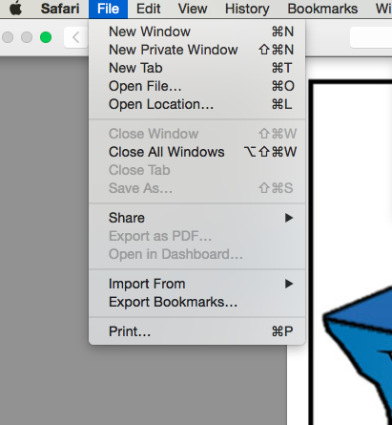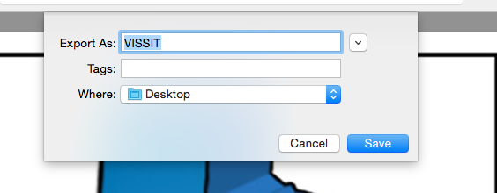
- Right click on the VISSIT file; choose open in and Adobe. If adobe is not a choice you can download it for free here: https://get.adobe.com/reader/

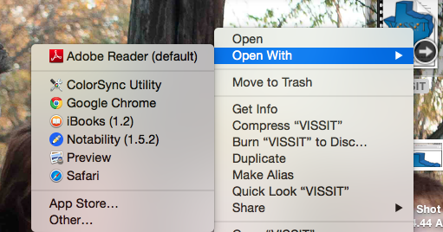

To open the form on you ios device: (ipad, iphone)
- Download Adobe Reader from the itunes store (free)
- Select open in at the top of the document.
- Choose Adobe Reader
