www.positiveeye.co.uk
Guess the message! Social Skills Game for Children and Young People with Visual Impairment
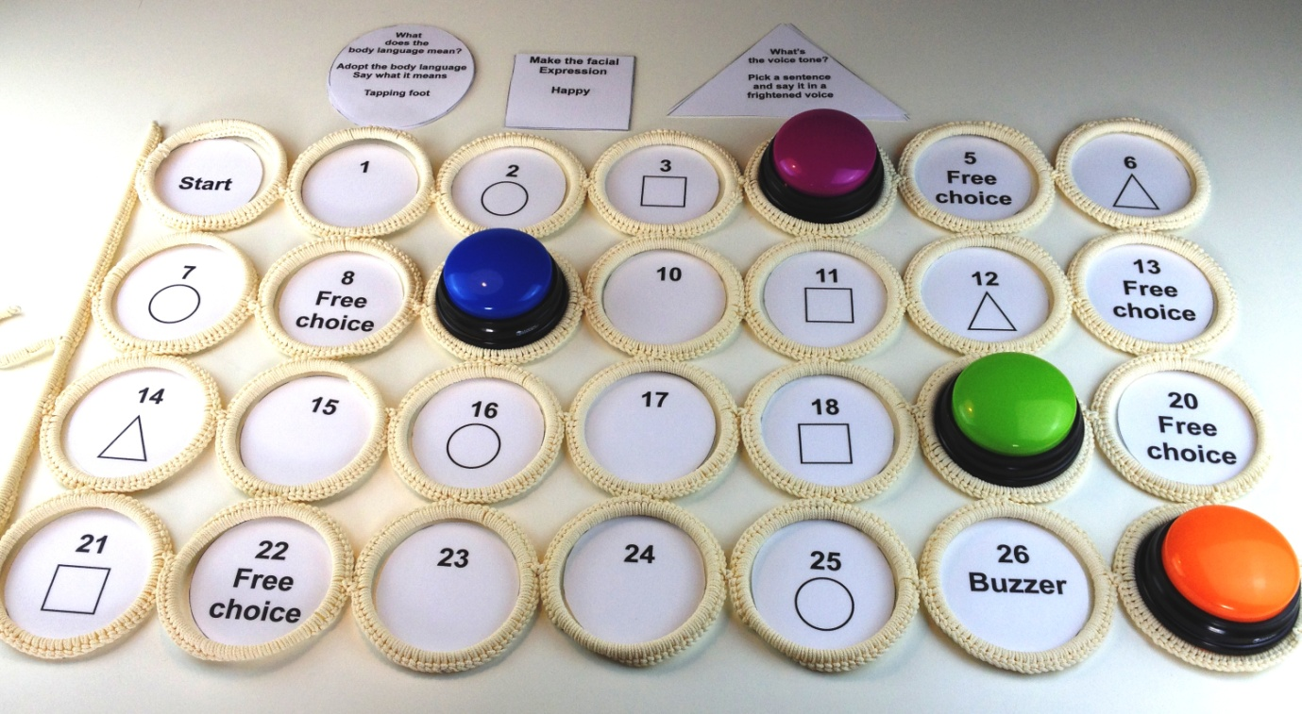
You will need:
1 multi hanger (KOMPLEMENT) from IKEA (£4.50) http://www.ikea.com/gb/en/catalog/products/70108912/
1 set of numbers to place in each circle of the hanger. (See attached sheet.) Cut out and laminated.
1 set of ‘Make the Facial Expression’ (square) cards. Cut out and laminated
1 set of ‘What does the body language mean?’ (Circular) cards. Cut out and laminated.
1 set of ‘What’s the voice tone?’ (Triangular) cards. Cut out and laminated.
I set of sentences to read in the voice tone as indicated on the triangular cards. Cut out and laminated.
1 set of ‘Top Tips for Positive Social Experience, cut out and laminated.
1 set of 4 buzzers - £15.95 (www.learningresources.com)
http://www.learningresources.co.uk/product/answer-buzzers.do?sortby=bestSellers&from=Search
1 dice
Counters, one per person playing
1 x A1 black card to lay the hanger on
Velcro or blu tack.
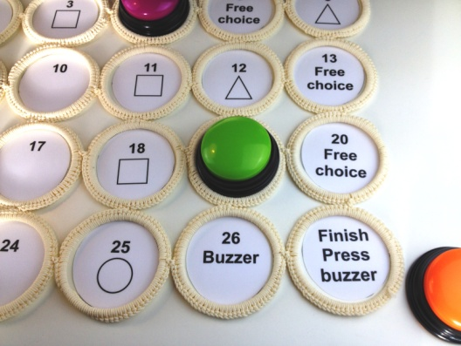
How to play (Players 2 – 6)
1. Lay the hanger flat on the table on a well contrasting surface.
2. Place the numbers cards in each of the circles Start – 1 – 26 – Finish Velcro/blu tack in place.
3. Place the buzzers on the buzzer cards
4. Place the circle, square, triangle cards alongside the hanger
5. Throw the dice. Player needs to throw a 6 to start
6. Players move along the board in numerical order, taking it in turns to throw the dice. The winner is the first to reach the finish line.
7. Along the way the player will land on numbers, numbers with a shape (circle, square, triangle) free choice or buzzer cards and will be requested to complete activities see below.
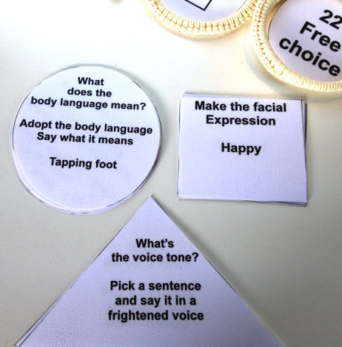
Landing on a number with a square: Pick a square card (Make the facial expression) and make the facial expression on the card, other players to guess the facial expression. (Describe facial expression if required.)
Landing on a number with a triangle: Pick a triangular card (What’s the voice tone?) and pick a sentence to read. Read the sentence in the voice indicated on the triangle card. Other players to guess the voice tone and the emotion conveyed.
Landing on a number with a circle: Pick a circular card (What does the body language mean?) and adopt the body language indicated on the card. Describe the emotion being conveyed. (Describe the posture if required.)
Landing on a buzzer: Give the buzzer a big press and pick a top tip for positive social experience and read it out to the other players
Landing on free choice: make a free choice from the options above.

