Instructions for a Seal with a Ball on his Nose
By Edith West
25 Rows & 36 cells
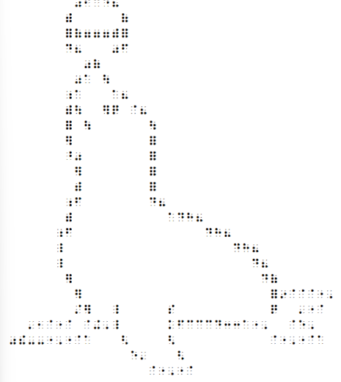
Row 1: Space 8 times, make “was”, make “f”, make “c”, make “d”, make “his”.
Row 2: Space 7 times, make “with”, space 5 times, make “of”.
Row3: Space 7 times, make 1 full cell, make “of”, make “gg” 3 times, make “with”, make 1 full cell.
Row 4: Space 7, make “d”, make “his, space 3 times, make “was”, make “f”.
Row 5: Space 9 times, make “was”, make “of”.
Row 6: Space 8 times, make “was”, make “a”, space 1 time, make “ou”.
Row 7: Space 7 times, make cell (5,6), make “a”, space 3 time, make “a”, make “his”.
Row 8, Space 7 times, make “with”, make “ou”, space 2 times, make “er”, make “q”, space 1 time, make “dot 4, make “his”.
Row 9: Space 7 times, make 1 full cell, space 1 time, make “ou”, space 6 times, make “ou”.
Row 10: Space 7 times, make “er”, space 8 times, make 1 full cell.
Row 11: Space 7 times, make cell (4,5), make “was”, space 7 times, make 1 full cell.
Row 12: Space 8 times, make “er”, space 7 times, make 1 full cell.
Row 13: Space 8 times, make “with, space 7 times, make 1 full cell.
Row 14: Space 7 times, make cell (5,6), make “f”, space 7 times, make “d”, make “his”.
Row 15: Space 7 times, make “with”, space 10 times, make dot 4, make “d”, make “h”, make “his”.
Row 16 Space 6 times: make cell (5,6), make “f”, space 14 times, make “d”, make “h”, make “his”.
Row 17: Space 6 times, make cell (4,5,6), space 18 times, make “d”, make “h”, make “his”.
Row 18: Space 6 times, make cell (4,5,6), space 20 times, make “d”, make “his”.
Row 19: Space 7 times, make “er”, space 20 times, make “d”, make “of”.
Row 20: Space 8 times, make “er”, space 20 times, make 1 full cell, make “in”, make dot 4 - 3 times, make dot 5, make dot 6.
Row 21: Space 8 times, make “st”, make “er”, space 2 times, make cell (4,5,6), space 5 times, make “s”, space 10 times, make “q”, space 2 times, make dot 3, make dot 5, make dot 4.
Row 22: Space 3 times, make dot 3, make dot 2, make dot 1, make dot 4, make dot 1, space 1 time, make dot 4, make “u”, make dot 6, make cell (4,5,6), space 5 times, make “k”, make “f”, make “c” 3 times, make “d”, make “cc” 2 times, make “a”, make dot 5, make dot 6, space 2 times, make dot 4, make “e”, make dot 6.
Row 23: Space 1 time, make “was, make “the”, make hyphen 2 times, make dot 5, make dot 6, make dot 5, make dot 4, make “a”, space 3 times, make “gh”, space 4 times, make “gh”, space 10 times, make dot 4, make dot 5, make dot 6, make dot 5, make dot 4, make “a”.
Row 24: Space 14 times, make “e”, make dot 3, space 3 times, make “ar”.
Row 25: Space 16 times, make dot 4, make dot 5, make dot 6, make dot 5, make dot 4.

